

|  |
| --- |
| Capstone Project Document |

**BOOKAHOLIC SOCIAL NETWORK**

Software Requirement Specifications

|  |  |  |
| --- | --- | --- |
| **Bookaholic Social Network** | | |
| **Group Members** | Phạm Thị Huyền | SE03416 |
| Thái Thị Cẩm Vân | SE03409 |
| Vũ Hải Đăng | SE03380 |
| Nguyễn Thị Hải Yến | SE03171 |
| Chu Minh Hải | SE03143 |
| **Supervisor** | Mr. Nguyễn Văn Sang | |
| **Project code** | BSN | |

**- Hanoi, 09/2016 -**

# SIGNATURE PAGE

|  |  |  |
| --- | --- | --- |
| AUTHOR: | Phạm Thị Huyền  Project manager  Nguyễn Thị Hải Yến  Team member  Chu Minh Hải  Team member | 09/16/2016 |
| REVIEWERS: | ----  Team member | --/--/2016 |
| APPROVAL: | Nguyễn Văn Sang  Supervisor | --/--/2016 |

**Record of change**

*A - Added M - Modified D – Deleted

|  |  |  |  |  |  |
| --- | --- | --- | --- | --- | --- |
| Effective Date | Changed Item | A,M,D | Change Description | Reason for Change | Rev. Number |
| 09/16/2016 | Create | A | Create | First version | 1.0 |
| 10/21/2016 | Update | M | Add new functions | Add new functions of phase 2 | 1.1 |
| 11/25/2016 | Update | M | Add new functions | Add new functions of phase 3 | 1.2 |

Table of Contents

SIGNATURE PAGE 2

1. INTRODUCTION 3

1.1. Purpose 3

1.2. Definitions and Acronyms 4

1.3. System Purpose 4

2. OVERALL DESCRIPTION 4

2.1. System overview 4

2.2. Use Case Diagram 4

2.3. Product Features 5

2.3.1. User Characteristics 5

2.3.2. User Documentation 5

2.3.3. Assumption 5

2.4. Entity Relation Model 5

2.4.1. Entity-Relationship Diagram 5

2.4.2. Entity Detail 5

3. FUNCTIONAL SPECIFICATION 5

3.1. Business Rules 5

3.2. Use Cases 5

4. NON-FUNCTIONAL SPECIFICATION 5

4.1. Reliability 5

4.2. Performance Requirements 5

4.2.1. Availability 5

4.2.2. Response time 5

4.2.3. Maintainability 5

4.2.4. Usability 5

4.2.5. Security Requirements 5

4.2.6. Hardware/Software Requirements 5

# INTRODUCTION

## **Purpose**

This document is created as the introduction for project Bookaholic Social Network – our Capstone Project at FPT University. In this document, we provide the describing of general requirement and non-functional requirements. These requirements will assure that the system will correctly and reliably perform its intended functionality. This specification will provide general, as well as specific requirements to be used in the design, testing and validation of the system. It is intended for both stakeholders and the project team of the system.

## **Definitions and Acronyms**

|  |  |  |
| --- | --- | --- |
| **Acronym** | **Definition** | **Note** |
| BSN | Bookaholic Social Network |  |
| SRS | Software Requirements Specifications |  |
| UC | Use Case |  |

Table 1‑1: Definition and Acronyms

## **System purpose**

Nowadays, social network plays an essential role in our lives. Vietnam is the country that has the big Internet user growth and the trend of communication through social network is expanding rapidly, people shares and discuses about everything through social network. However, there is not any social network that is for only Vietnamese people who love reading books. To solve this problem, we create a website where people who loves book can share and discus with others about their favorite books or authors. We believe this project will strengthen Vietnam’s reading culture.

# OVERALL DESCRIPTION

## **System overview**

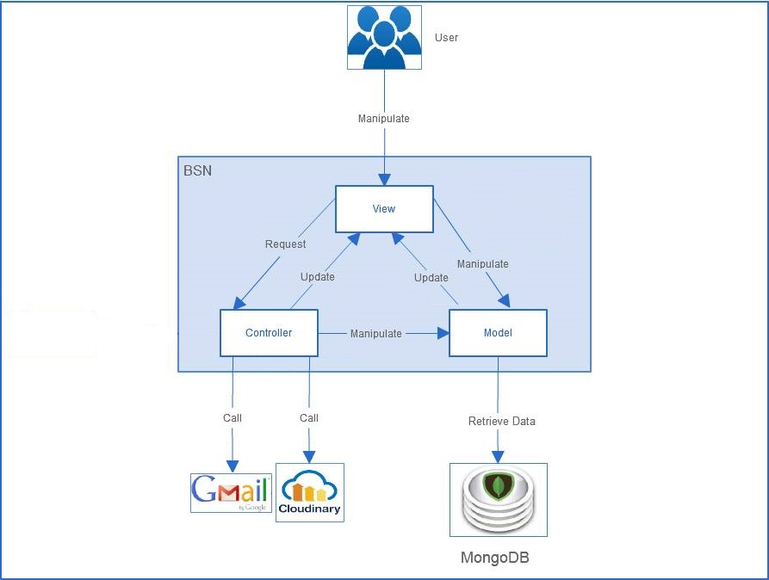

Figure 2‑1: BSN System Overview

## **Product Features**

|  |  |  |  |
| --- | --- | --- | --- |
| **Use Case No.** | **Group of functions** | **Functions** | **Glossary** |
| **GUEST MODULE** | | | |
| **UC001** | Register | Register for a normal account | Register for a normal account (reader) |
| **UC002** | Register for an author account | Register for an author account: User must upload an image of their identity card and wait for approve from admin of website. |
| **READER/AUTHOR MODULE** | | | |
| **UC003** | Account | Login | Login by registered account |
| **UC004** | Logout | Logout |
| **UC005** | Edit personal information | Edit personal information includes name, email, address, date of birth. |
| **UC006** | Edit avatar and cover photo | Edit avatar and cover photo |
| **UC007** | Reset password | Reset password by confirm an auto email. |
| **UC008** | Post | Create a post | Create a post to introduce about book(s). User has to tag book(s) as the topic of that post. |
| **UC009** | Edit a post | Edit caption and book tags of a created post. |
| **UC010** | Delete a post | Delete posts |
| **UC011** | Like a post | Like posts |
| **UC012** | Unlike a post | Unlike posts |
| **UC013** | Comment on a post | Comment on a post |
| **UC014** | Delete a comment | Delete comments |
| **UC015** | Interaction | Follow user account | Follow other account to get their new post on new-feed. |
| **UC016** | Report user account | Report other accounts. |
| **UC017** | Send join-group request | Send join-group request. After that, users have to wait admin of that group to add them as members. |
| **UC018** | Leave a group | Members can leave a group themselves. |
| **UC019** | Report a group | Report groups. |
| **UC020** | Get Notification | Users get notification when: + Other users like their post + Other users comment on their post + Other users follow their account |
| **UC021** | Group | Create a group | To create a group, users have to tag a book/author as the topic of that group. |
| **UC022** | Edit group information | Edit group profile |
| **UC023** | Edit group's avatar/cover photo |  |
| **UC024** | Add new members | Add new members by enter account name. |
| **UC025** | Accept join-group request | Users can send a request to group and admin have right to accept them as members or not. |
| **UC026** | Set group's admin | Set other members in group as admins. |
| **UC027** | Remove a member | Admins of a group van remove other members from their group. |
| **UC028** | Create a group post | Create group posts: Members do not need to tag books or authors. |
| **UC029** | Like a group post |  |
| **UC030** | Edit a group post | Edit group posts. |
| **UC031** | Delete a group post | Delete group posts. |
| **UC032** | Comment on a group post |  |
| **UC033** | Delete comment on a group post |  |
| **UC034** | Book | Rate a book | Rate a book: the highest score is 5 stars. |
| **UC035** | Comment on a book | Comment about book in its own details page |
| **UC036** | View a book's details | View details about a book: image, description, rating and comments of readers about that book. |
| **UC037** | Search book/author/other account/group | Search book/author/other account/group |
| **UC038** | View suggested books/authors | BSN system suggests books/authors base on the trend of reading: + Book: by access times + Author: by number of followers |
| **ADMIN MODULE** | | | |
| **UC039** | User Accounts Management | Search user | Search user |
| **UC040** | Ban user | If an account is reported, admin of page has right to ban that account of decline the reporting request. |
| **UC041** | Unban user | Unban user |
| **UC042** | Decline request about reporting an account | If an account is reported, admin of page has right to ban that account of decline the reporting request. |
| **UC043** | Accept request about creating author account |  |
| **UC044** | Decline request about creating author account | Accept/decline request about creating author account from guests. |
| **UC045** | Groups Management | Band a group | When a group is reported, admin of page can band it. |
| **UC046** | Unban a group | Unban a group |
| **UC047** | Decline request about reporting a group |  |
| **UC048** | Books Management | Add a new book | Add new books. |
| **UC049** | Add a new Category | Add new Categories. |
| **UC050** | Add an author | Add Authors |
| **UC051** | Edit book's information | Edit book's information |
| **UC052** | Accept add-book request |  |
| **UC053** | Decline add-book request | Approve/decline requests about adding a book |
| **UC054** | Sliders Management | Add a new slider | Add new sliders to introduce about website. |
| **UC055** | Delete a slider | Delete sliders. |
| **UC056** | Active/de-active a slider | Active/de-active slides. |
| **UC057** | Show a slider | Display sliders on the login page. |
| **UC058** | Publishers Management | Add a new publisher | Add new publishers |
| **UC059** | Edit publisher' information | Edit publishers' information |
| **UC060** | Delete a publisher | Delete publisher |
| **UC061** | Statistics | View user statistic | View statistic about users: + number of old accounts + number of new accounts |
| View author statistic | View statistic about authors: + number of old accounts + number of new accounts + authors with largest number of followers |
| View group statistic | View statistic about groups: + number of old groups + number of new groups |
| View book statistic | View statistic about books: + number of old books + number of new books + the book in trend: base on number of access time |

### **User Characteristics**

BSN website aim towards to anyone loves books and looking for a website to share their thought and make friends with other readers. Below are main actors that our system supports:

* **Guest:** Users who have not created an account, they can use functions such as: register for a normal account or register for an author account.
* **Readers & Authors:** Users who have account on system, they can use almost functions of website. For example: searching, posting, rating, connect to friends, etc.
* **Administrators:** They have an administrator control panel to manage all configurations of system

### **User Documentation**

|  |  |
| --- | --- |
| Name | Description |
| User guideline | Provide detailed explanation about the system, screens and guide users how to use all features of BSN system. |
| Installation guide |  |

### **Assumption**

* Receive the guidance and good support from teacher.
* No one of members in group gets sick in the software development process.
* In the development process, no device gets fail.
* Every report meets the deadline.
* Team members do not conflict in the work process.

## **Entity Relation Model**

### **Entity-Relationship Diagram**

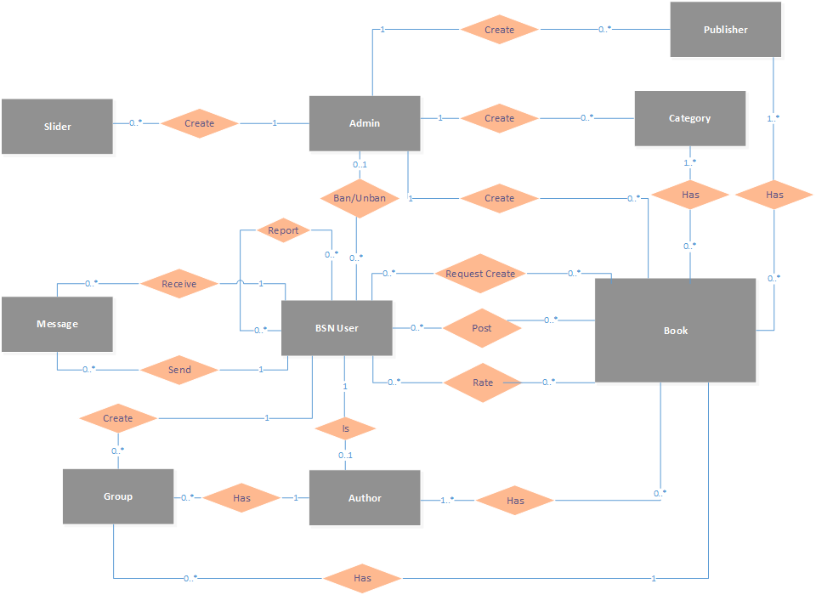

Figure 2‑2: Entity Relationship Diagram

### **Entity Detail**

#### 2.3.2.1 BSN User

|  |  |  |
| --- | --- | --- |
| No | Properties | Description |
| 1 | Name | User’s name |
| 2 | Email | User’s email |
| 3 | Password | User’s password |
| 4 | Role | User’s role (includes: reader, author, admin) |
| 5 | Gender | User’s gender |
| 6 | Avatar photo | User’s avatar photo |
| 7 | Cover photo | User’s cover photo |
| 8 | List followings | List users that this user is following |
| 9 | List followers | List users following this user |
| 10 | List messages | List messages of this user |

#### 2.3.2.2 Admin

|  |  |  |
| --- | --- | --- |
| No | Properties | Description |
| 1 | Name | Admin’s name |
| 2 | Email | Admins email |
| 3 | Password | Admin’s password |

#### 2.3.2.3 Author

|  |  |  |
| --- | --- | --- |
| No | Properties | Description |
| 1 | Name | Author’s name |
| 2 | Email | Author’s email |
| 3 | Password | Author’s password |
| 4 | Gender | Author’s gender |
| 5 | Avatar photo | Author’s avatar photo |
| 6 | Cover photo | Author’s cover photo |
| 7 | Address | Author’s address |
| 8 | SSN Image | Author’s SSB image |
| 9 | List followings | List users that this author is following |
| 10 | List followers | List users following this user |
| 11 | List messages | List messages of this user |
| 12 | List books | List books of this user |

#### 2.3.2.4 Book

|  |  |  |
| --- | --- | --- |
| No | Properties | Description |
| 1 | Name | Book’s name |
| 2 | Image | Book’s image |
| 3 | Release day | Book’s released day |
| 4 | Description | Book’s description |
| 5 | Rating point | Book’s sum of all rating points |
| 6 | Rating time | Book’s count number of rating time |
| 7 | List categories | List categories of this book |
| 8 | List publishers | List publishers of this books |
| 9 | List authors | List authors of this books |
| 10 | List comments | List comments of this books |

#### 2.3.2.5 Publisher

|  |  |  |
| --- | --- | --- |
| No | Properties | Description |
| 1 | Name | Publisher’s name |
| 2 | Address | Publisher’s address |
| 3 | Phone number | Publisher’s phone number |
| 4 | Image | Publisher’s image |

#### 2.3.2.6 Group

|  |  |  |
| --- | --- | --- |
| No | Properties | Description |
| 1 | Name | Group’s name |
| 2 | Status | Group’s status (locked or not) |
| 3 | Type | Group type (publish or private) |
| 4 | Created Date | Group’s created date |
| 5 | Tag | Group’s tag (book or author) |
| 6 | Description | Group’s description |
| 7 | Avatar photo | Group’s avatar photo |
| 8 | Cover photo | Group’s cover photo |
| 9 | List members | List members of this group |
| 10 | List requests | List requests to join this group |

#### 2.3.2.7 Message

|  |  |  |
| --- | --- | --- |
| No | Properties | Description |
| 1 | Time | Message’s sent time |
| 2 | Content | Message’s content |
| 3 | Status | Message’s status (delivered or not) |

#### 2.3.2.8 Slider

|  |  |  |
| --- | --- | --- |
| No | Properties | Description |
| 1 | Image | Slider’s image |
| 2 | Description | Slider’s description |
| 3 | Status | Slider’s Status (showed or not) |

#### 2.3.2.9 Category

|  |  |  |
| --- | --- | --- |
| No | Properties | Description |
|  | Name | Category’s name |

# FUNCTIONAL SPECIFICATION

## **Business Rules**

|  |  |
| --- | --- |
| No | Description |
| B1 | Email must content characters ‘@’ and ‘.’ |
| B2 | Authors must have CMND photo. |
| B3 | Allowed file extension: .jpg, .png |
| B4 | The tag book must be attached when user posting a new post. |
| B5 | Displayed date is dd/mm/yyyy format |
| B6 | Date time input format is datetime |

## **Use Cases**

### 3.2.1 Guest Module

#### 3.2.1.1 Register

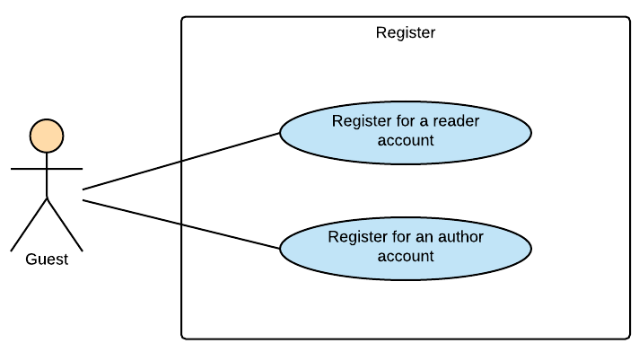

Figure 3‑1: Guest Module - Register

##### 3.2.1.1.1 UC001-Register for a normal account

###### 3.2.1.1.1 .1 Use Case Specification - Normal flow

|  |  |  |  |  |
| --- | --- | --- | --- | --- |
| **Use Case ID** | | UC001 | **Version** | 1.0 |
| **Use Case Name** | | Register for a normal account | | |
| **Created by:** | | HaiCM | **Date Created:** | 09/16/2016 |
| **Primary Actor** | | Guest | **Secondary Actor** | N/A |
| **Description:** | | This function allow guests to register for a normal account (reader account) | | |
| **Preconditions:** | | 1. Guest are viewing Login-register page  2. Enter information in register form | | |
| **Trigger:** | | Click on “Đăng ký” button on the website | | |
| **Post conditions:** | | Confirm mail has sent to guest’s email. | | |
| **Normal Flow** | | | | |
| **Step** | **Actor** | **Action** | | |
| 1 | User | Enter BSN website | | |
| 2 | BSN | Display Login-register page includes:   * Email textbox * Password textbox * Login button: “Đăng nhập” * Forgot password hyperlink: “Bạn quên?” * Account name textbox on register form * Email textbox on register form * Password textbox on register form * Author registers hyperlink: “Tác giả đăng ký”   Sign up button: “Đăng ký” | | |
| 3 | User | Enter information in register form on website | | |
| 4 | User | Click “Đăng ký” button | | |
| 5 | BSN | Send confirm email | | |
| 6 | User | Follow guide in confirm email | | |
| 7 | BSN | Confirm account | | |
| 8 | BSN | Redirects user to Login-register page | | |
| **Priority** | | High | | |
| **Frequency of Use:** | | High | | |
| **Business Rules:** | | B1 | | |
| **Other Information:** | | N/A | | |

###### 3.2.1.1.1 .2 Alternative Flows and Exceptions

|  |  |  |  |  |
| --- | --- | --- | --- | --- |
| **Alternative Flows:** | | | | |
| **AT1** | At step 4 in the main flows, if user click other hyperlinks or buttons | | | |
| **Step** | **Actor** | | **Action** | |
| 4.1 | BSN | | Redirects user to chosen hyperlink or button | |
| **Exceptions:** | | | | |
| **EC1** | | At step 4, required fields are not entered | | |
| **Step** | | **Actor** | | **Action** |
| 4.1 | | BSN | | Display Login-register page with message: with MS01 |
| 4.1 | | BSN | | Mark error fields |
|  | |  | |  |
| **EC2** | | At step 4, fields are entered with wrong type of data | | |
| **Step** | | **Actor** | | **Action** |
| 4.1 | | BSN | | Display Login-register page with message: with MS01 |
| 4.2 | | BSN | | Mark error fields |

##### 3.2.1.1.2 UC002-Register for an author account

###### 3.2.1.1.2 .1 Use Case Specification - Normal flow

|  |  |  |  |  |
| --- | --- | --- | --- | --- |
| **Use Case ID** | | UC002 | **Version** | 1.0 |
| **Use Case Name** | | Register for an author account | | |
| **Created by:** | | HaiCM | **Date Created:** | 09/16/2016 |
| **Primary Actor** | | Guest | **Secondary Actor** | N/A |
| **Description:** | | This function allows guests to register for an author account. | | |
| **Preconditions:** | | 1. Display Author register page  2. Enter information in author register form | | |
| **Trigger:** | | Click on register button on the website | | |
| **Post conditions:** | | Confirm mail has sent to guest’s email | | |
| **Normal Flow** | | | | |
| **Step** | **Actor** | **Action** | | |
| 1 | User | Enter BSN website | | |
| 2 | User | Click “Tác giả đăng ký” hyperlink | | |
| 3 | BSN | Display Author register page includes:   * Email textbox * Password textbox * Login button: “Đăng nhập” * Forgot password hyperlink: “Bạn quên?” * Account name textbox on register form * Email textbox on register form * Password textbox on register form * Choose file button   - Sign up button: “Đăng ký” | | |
| 4 | User | Enter information in register form on website and upload an identification image | | |
| 5 | User | Click “Đăng ký” button | | |
| 6 | BSN | Send confirm email | | |
| 7 | User | Follow guide in confirm email | | |
| 8 | BSN | Confirm account | | |
| 9 | BSN | Redirects user to Login-register page | | |
| **Priority** | | High | | |
| **Frequency of Use:** | | High | | |
| **Business Rules:** | | B1 B2 B3 | | |
| **Other Information:** | | N/A | | |

###### 3.2.1.1.2 .2 Alternative Flows and Exceptions

|  |  |  |  |  |
| --- | --- | --- | --- | --- |
| **Alternative Flows:** | | | | |
| **AT1** | At step 5 in the main flows, if user click other hyperlinks or buttons | | | |
| **Step** | **Actor** | | **Action** | |
| 5.1 | BSN | | Redirects user to chosen hyperlink or button | |
|  | | | | |
| **Exceptions: N/A** | | | | |
| **EC1** | | At step 5, required fields are not entered | | |
| **Step** | | **Actor** | | **Action** |
| 5.1 | | BSN | | Display Login-register page with message: with MS01 – MS09 |
| 5.2 | | BSN | | Mark error fields |
|  | |  | |  |
| **EC2** | | At step 5, fields are entered with wrong type of data | | |
| **Step** | | **Actor** | | **Action** |
| 5.1 | | BSN | | Display Login-register page with message: with MS01 – MS09 |

### 3.2.2 Reader/Author Module

#### 3.2.2.1 Account

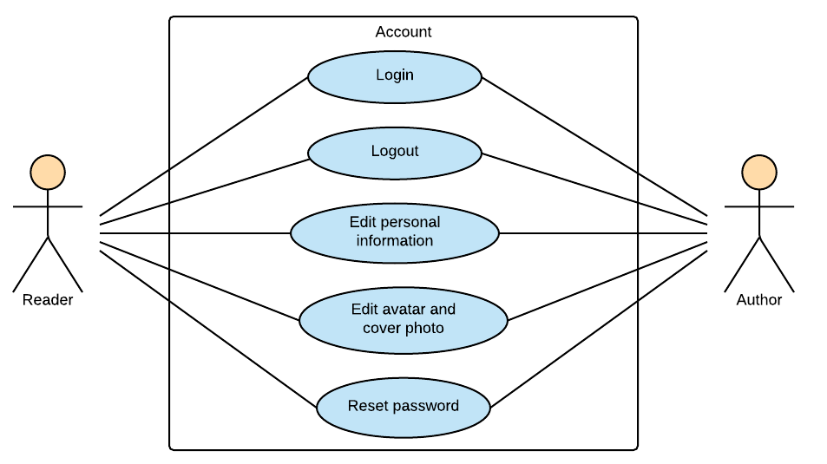

Figure 3‑2: Reader/Author Module - Account

##### 3.2.2.1.1 UC003-Login

###### 3.2.2.1.1 .1 Use Case Specification - Normal flow

|  |  |  |  |  |
| --- | --- | --- | --- | --- |
| **Use Case ID** | | UC001 | **Version** | 1.0 |
| **Use Case Name** | | Login | | |
| **Created by:** | | HaiCM | **Date Created:** | 09/16/2016 |
| **Primary Actor** | | Registered User | **Secondary Actor** | N/A |
| **Description:** | | This function allows users to login system by registered account. | | |
| **Preconditions:** | | 1. Account must be existed.  2. Display login-register page. | | |
| **Trigger:** | | Click Login button (“Đăng nhập”) | | |
| **Post conditions:** | | 1. Validate account success  2. Display home page as reader or author’s interface. | | |
| **Normal Flow** | | | | |
| **Step** | **Actor** | **Action** | | |
| 1 | User | Enter BSN location on browser | | |
| 2 | BSN | Display login-register page includes:   * Email textbox * Password textbox * Login button: “Đăng nhập” * Forgot password hyperlink: “Bạn quên?” * Account name textbox on register form * Email textbox on register form * Password textbox on register form * Confirm password textbox on register form * Author register hyperlink: “Tác giả đăng ký”   Sign up button: “Đăng ký” | | |
| 3 | User | Enters email and password | | |
| 4 | User | Click “Đăng nhập” button | | |
| 5 | BSN | Logs user into system | | |
| 6 | BSN | Display home page as normal user or author’s interface. | | |
| **Priority** | | High | | |
| **Frequency of Use:** | | High | | |
| **Business Rules:** | | B1 | | |
| **Other Information:** | | N/A | | |

###### 3.2.2.1.1 .2 Alternative Flows and Exceptions

|  |  |  |  |  |  |  |
| --- | --- | --- | --- | --- | --- | --- |
| **Alternative Flows:** | | | | | | |
| **AT1** | At step 4 in the main flows, if user click other hyperlinks or buttons | | | | | |
| **Step** | **Actor** | | | **Action** | | |
| 4.1 | BSN | | | Redirects user to chosen hyperlink or button | | |
|  | | | | | | |
| **AT2** | | At step 4 in the main flows**,** if BSN failed to validate user name & password | | | | |
| **Step** | | **Actor** | | | **Action** | |
| 4.1 | | BSN | | | Display Login page with message MS01 MS02 | |
|  | | | | | | |
| **Exceptions:** | | | | | | |
| **EC1** | | | At step 3 in main flow, if user entered wrong email or password | | | |
| **Step** | | | **Actor** | | | **Action** |
| 3.1 | | | BSN | | | Display Login popup message with MS01 MS02 |

##### 3.2.2.1.2 UC004-Logout

###### 3.2.2.1.2 .1 Use Case Specification - Normal flow

|  |  |  |  |  |
| --- | --- | --- | --- | --- |
| **Use Case ID** | | UC004 | **Version** | 1.0 |
| **Use Case Name** | | Logout | | |
| **Created by:** | | HaiCM | **Date Created:** | 09/16/2016 |
| **Primary Actor** | | Registered User | **Secondary Actor** | N/A |
| **Description:** | | This function allow user to log out system. | | |
| **Preconditions:** | | User logged in to system | | |
| **Trigger:** | | User click “Đăng xuất” on dropdown list from setting icon in navigation bar | | |
| **Post conditions:** | | 1. Log user out from system.  2. Display login-register page | | |
| **Normal Flow** | | | | |
| **Step** | **Actor** | **Action** | | |
| 1 | User | Click “Đăng xuất” button | | |
| 2 | BSN | Display login-register page | | |
| **Priority** | | High | | |
| **Frequency of Use:** | | High | | |
| **Business Rules:** | | N/A | | |
| **Other Information:** | | N/A | | |

###### 3.2.2.1.2 .2 Alternative Flows and Exceptions

|  |
| --- |
| **Alternative Flows: N/A** |
| **Exceptions: N/A** |

##### 3.2.2.1.3 UC005-Edit personal Information

###### *3.2.2.1.3 .1 Use Case Specification - Normal flow*

|  |  |  |  |  |
| --- | --- | --- | --- | --- |
| **Use Case ID** | | UC005 | **Version** | 1.0 |
| **Use Case Name** | | Edit personal Information | | |
| **Created by:** | | HaiCM | **Date Created:** | 09/16/2016 |
| **Primary Actor** | | Reader | **Secondary Actor** | Author |
| **Description:** | | This function allows users to edit personal information includes name, email, address, date of birth. | | |
| **Preconditions:** | | User logged in BSN website | | |
| **Trigger:** | | User click “Chỉnh sửa thông tin” hyperlink while in home page then click save button (“Lưu”) | | |
| **Post conditions:** | | Updated information display in edit profile page | | |
| **Normal Flow** | | | | |
| **Step** | **Actor** | **Action** | | |
| 1 | User | Click “Chỉnh sửa thông tin” hyperlink while in home page | | |
| 2 | BSN | Display Edit profile page includes:   * Navigation bar * User profile panel * Side bars   User’s information | | |
| 3 | BSN | Display user’s information and editable text box | | |
| 4 | User | Modifies fields | | |
| 5 | User | Click “Lưu” button | | |
| 6 | BSN | Display home page with updated information | | |
| **Priority** | | High | | |
| **Frequency of Use:** | | High | | |
| **Business Rules:** | | N/A | | |
| **Other Information:** | | N/A | | |

###### 3.2.2.1.3 .2 Alternative Flows and Exceptions

|  |  |  |  |  |
| --- | --- | --- | --- | --- |
| **Alternative Flows:** | | | | |
| **AT1** | At step 4 in the main flows, if user click other hyperlinks or buttons | | | |
| **Step** | **Actor** | | **Action** | |
| 4.1 | BSN | | Redirects user to chosen hyperlink or button | |
|  | | | | |
| **Exceptions:** | | | | |
| **EC1** | | At step 5, fields are entered with wrong type of data | | |
| **Step** | | **Actor** | | **Action** |
| 5.1 | | BSN | | Display Edit profile page with message: MS 07 |
| 5.2 | | BSN | | Mark error fields |
|  | |  | |  |
| **EC2** | | At step 5, fields are null | | |
| **Step** | | **Actor** | | **Action** |
| 5.1 | | BSN | | Disable “Lưu” button |

##### 3.2.2.1.4 UC006-Edit avatar and cover photo

###### *3.2.2.1.4 .1 Use Case Specification - Normal flow*

|  |  |  |  |  |
| --- | --- | --- | --- | --- |
| **Use Case ID** | | UC006 | **Version** | 1.0 |
| **Use Case Name** | | Edit avatar and cover photo | | |
| **Created by:** | | YenNTH | **Date Created:** | 09/16/2016 |
| **Primary Actor** | | Reader | **Secondary Actor** | Author |
| **Description:** | | This function allows users to edit their avatar and cover photo. | | |
| **Preconditions:** | | User logged in BSN website | | |
| **Trigger:** | | User click camera icon on the avatar or cover to edit avatar or cover photo | | |
| **Post conditions:** | | Avatar photo or cover photo is edited . | | |
| **Normal Flow** | | | | |
| **Step** | **Actor** | **Action** | | |
| 1 | Reader/Author | Click icon camera on the avatar or cover | | |
| 2 | BSN | Display form to choose avatar photo or cover photo | | |
| 3 | Reader/Author | Choose avatar photo or cover photo | | |
| 4 | BNS | Update avatar photo or cover photo | | |
| **Priority** | | High | | |
| **Frequency of Use:** | | High | | |
| **Business Rules:** | | B3 | | |
| **Other Information:** | | N/A | | |

###### *3.2.2.1.4.2* Alternative Flows and Exceptions

|  |  |  |  |
| --- | --- | --- | --- |
| **Alternative Flows:** | | | |
| **AT1** | At step 3 in the main flows, if user click cancel | | |
| **Step** | **Actor** | **Action** | |
| 3.1 | BSN | | Form choose avatar photo or cover photo will be close |
| **AT2** | At step 3 in the main flows, if user choose file is not .jpg .png | | |
| **Step** | **Actor** | | **Action** |
| 3.1 | BSN | | Display message MS32 |
|  | | | |
| **Exceptions: N/A** | | | |

##### 3.2.2.1.5 UC007-Reset password

###### 3.2.2.1.5 .1 Use Case Specification - Normal flow

|  |  |  |  |  |
| --- | --- | --- | --- | --- |
| **Use Case ID** | | UC007 | **Version** | 1.0 |
| **Use Case Name** | | Reset password | | |
| **Created by:** | | HaiCM | **Date Created:** | 09/16/2016 |
| **Primary Actor** | | Reader | **Secondary Actor** | Author |
| **Description:** | | This function allows users to reset their password through email. | | |
| **Preconditions:** | | 1. User’s account must be existed and correct.  2. User browsed BSN website | | |
| **Trigger:** | | Click “Bạn quên?” hyperlink in Login-register page | | |
| **Post conditions:** | | Reset password has sent to user’s email | | |
| **Normal Flow** | | | | |
| **Step** | **Actor** | **Action** | | |
| 1 | User | Click “Bạn quên?” hyperlink in Login-register page | | |
| 2 | BSN | Display reset password popup included:   * Email text box   “Gửi” and “Đóng” buttons | | |
| 3 | User | Enter registered email | | |
| 4 | User | Click “Gửi” button | | |
| 5 | BSN | Sends reset password email | | |
| 6 | BSN | Close popup | | |
| 7 | User | Follow guide in email | | |
| **Priority** | | High | | |
| **Frequency of Use:** | | High | | |
| **Business Rules:** | | N/A | | |
| **Other Information:** | | N/A | | |

###### 3.2.2.1.5 .2 Alternative Flows and Exceptions

|  |  |  |  |  |  |  |
| --- | --- | --- | --- | --- | --- | --- |
| **Alternative Flows:** | | | | | | |
| **AT1** | At step 3 in the main flow, user clicks on “Đóng” button | | | | | |
| **Step** | **Actor** | | | **Action** | | |
| 3.1 | BSN | | | Close pop-up | | |
|  | | | | | | |
| **AT2** | | At step 4 in the main flows, if user click other hyperlinks or buttons | | | | |
| **Step** | | **Actor** | | | **Action** | |
| 4.1 | | BSN | | | Redirects user to chosen hyperlink or button | |
|  | | | | | | |
| **Exceptions:** | | | | | | |
| **EC1** | | | At step 4, entered email is invalid or does not exist in databas | | | |
| **Step** | | | **Actor** | | | **Action** |
| 4.1 | | | BSN | | | Displays popup with message: with MS01 |

#### 3.2.2.2 Post

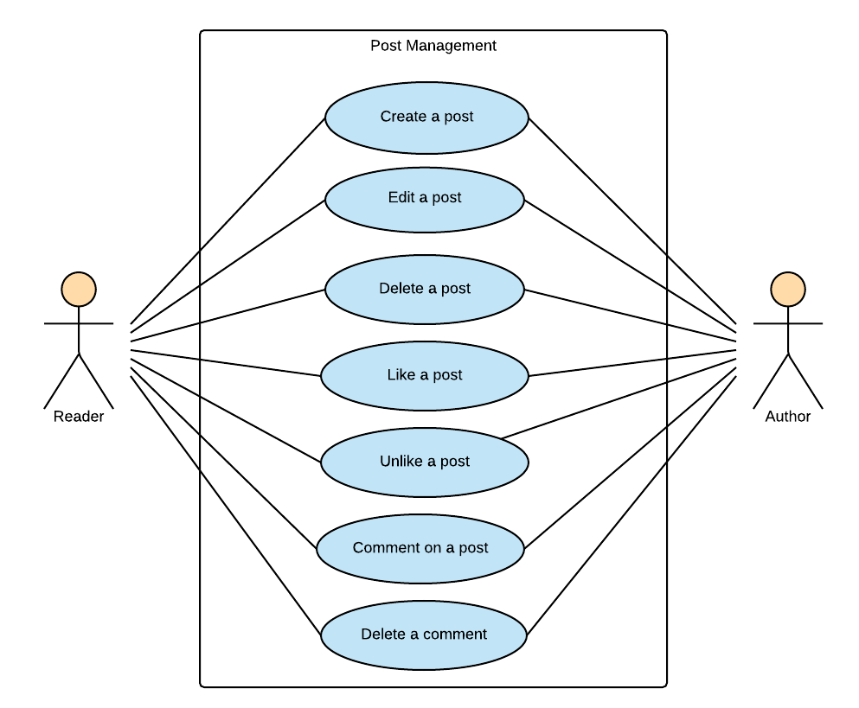

Figure 3‑3: Reader/Author Module-Post

##### 3.2.2.2.1 UC008-Create a post

###### 3.2.2.2.1 .1 Use Case Specification - Normal flow

|  |  |  |  |  |
| --- | --- | --- | --- | --- |
| **Use Case ID** | | UC008 | **Version** | 1.0 |
| **Use Case Name** | | Create a post | | |
| **Created by:** | | HaiCM | **Date Created:** | 10/21/2016 |
| **Primary Actor** | | Reader | **Secondary Actor** | Author |
| **Description:** | | This function allows users to create a post to introduce about books. | | |
| **Preconditions:** | | User logged in BSN website | | |
| **Trigger:** | | Click “Đăng” button on recommendation area | | |
| **Post conditions:** | | New recommendation displays on home page or personal page | | |
| **Normal Flow** | | | | |
| **Step** | **Actor** | **Action** | | |
| 1 | User | Enter Home page or Personal page | | |
| 2 | User | Click text area and enter a recommendation | | |
| 3 | User | Click tag book | | |
| 4 | User | Input and enter book’s name or author’s name | | |
| 5 | BSN | Search book’s name or author’s name in database then show results | | |
| 6 | User | Choose a tag | | |
| 7 | User | Click “Đăng” button | | |
| 8 | BSN | Displays new recommendation on home page or personal page | | |
| **Priority** | | High | | |
| **Frequency of Use:** | | High | | |
| **Business Rules:** | | N/A | | |
| **Other Information:** | | N/A | | |

###### 3.2.2.2.1.2 Alternative Flows and Exceptions

|  |  |  |  |  |
| --- | --- | --- | --- | --- |
| **Alternative Flows:** | | | | |
| **AT1** | At step 6 in the main flows, if user click other hyperlinks or buttons | | | |
| **Step** | **Actor** | | **Action** | |
| 6.1 | BSN | | Redirects user to chosen hyperlink or button | |
|  | | | | |
| **Exceptions:** | | | | |
| **EC1** | | At step 7, book’s tag does not chosen | | |
| **Step** | | **Actor** | | **Action** |
| 1 | | BSN | | Display viewing page with message: with MS19 |
| 2 | | BSN | | Mark error fields |
| **EC2** | | At step 5, BSN system cannot search any book or author | | |
| **Step** | | **Actor** | | **Action** |
| **1** | | BSN | | No data to display for the reader/author to choose |
| **2** | | BSN | | Mark error fields |

##### 3.2.2.2.2 UC009-Edit a post

###### 3.2.2.2.2 .1 Use Case Specification - Normal flow

|  |  |  |  |  |
| --- | --- | --- | --- | --- |
| **Use Case ID** | | UC009 | **Version** | 1.0 |
| **Use Case Name** | | Edit a post | | |
| **Created by:** | | HaiCM | **Date Created:** | 10/21/2016 |
| **Primary Actor** | | User | **Secondary Actor** | N/A |
| **Description:** | | This function allows users to edit caption and book tags of a created post. | | |
| **Preconditions:** | | User is viewing their own recommendation | | |
| **Trigger:** | | Click “Sửa” hyperlink on angle-down icon at top-right of the post | | |
| **Post conditions:** | | Caption has changed | | |
| **Normal Flow** | | | | |
| **Step** | **Actor** | **Action** | | |
| 1 | User | Viewing personal’s recommendation | | |
| 2 | User | Click “Sửa” hyperlink on angle-down icon at top-right of the post | | |
| 3 | BSN | Display recommendation with text area and book’s tag editable | | |
| 4 | User | Modifies caption | | |
| 5 | User | Click “Đăng” button | | |
| 6 | BSN | Changes caption | | |
| **Exceptions:** | | | | |
| **Priority** | | High | | |
| **Frequency of Use:** | | High | | |
| **Business Rules:** | | N/A | | |
| **Other Information:** | | N/A | | |

###### 3.2.2.2.2 .2 Alternative Flows and Exceptions

|  |  |  |
| --- | --- | --- |
| **Alternative Flows:** | | |
| **AT1** | At step 4 in the main flows, if user click other hyperlinks or buttons | |
| **Step** | **Actor** | **Action** |
| 4.1 | BSN | Redirects user to chosen hyperlink or button |
| **AT1** | At step 5 in the main flows, if caption is null | |
| **Step** | **Actor** | **Action** |
| 5.1 | BSN | Disable “Đăng” button |
| **Exceptions: N/A** | | |

##### 3.2.2.2.3 UC010-Delete a post

###### 3.2.2.2.3.1 Use Case Specification - Normal flow

|  |  |  |  |  |
| --- | --- | --- | --- | --- |
| **Use Case ID** | | UC010 | **Version** | 1.0 |
| **Use Case Name** | | Delete a post | | |
| **Created by:** | | HaiCM | **Date Created:** | 10/21/2016 |
| **Primary Actor** | | User | **Secondary Actor** | N/A |
| **Description:** | | This function use to remove a recommendation | | |
| **Preconditions:** | | User is viewing their recommendation | | |
| **Trigger:** | | Click “Xóa” hyperlink on angle-down icon at top-right of the post | | |
| **Post conditions:** | | Recommendation has removed from home page or personal page | | |
| **Normal Flow** | | | | |
| **Step** | **Actor** | **Action** | | |
| 1 | User | Viewing personal’s recommendation | | |
| 2 | User | Click “Xóa” hyperlink on angle-down icon at top-right of the recommendation | | |
| 3 | BSN | Delete chosen post | | |
| 4 | BSN | Refresh viewing page in real-time | | |
| **Priority** | | High | | |
| **Frequency of Use:** | | High | | |
| **Business Rules:** | | N/A | | |
| **Other Information:** | | N/A | | |

###### 3.2.2.2.3.2 Alternative Flows and Exceptions

|  |  |  |
| --- | --- | --- |
| **Alternative Flows:** | | |
| **AT1** | At step 2 in the main flows, if user click drop down list icon again | |
| **Step** | **Actor** | **Action** |
| 2.1 | BSN | Close drop down list |
| **Exceptions: N/A** | | |

##### 3.2.2.2.4 UC011-Like a post

###### 3.2.2.2.4.1 Use Case Specification - Normal flow

|  |  |  |  |  |
| --- | --- | --- | --- | --- |
| **Use Case ID** | | UC011 | **Version** | 1.0 |
| **Use Case Name** | | Like a post | | |
| **Created by:** | | HaiCM | **Date Created:** | 10/21/2016 |
| **Primary Actor** | | User | **Secondary Actor** |  |
| **Description:** | | This function allows user to like others’ post and their own post. | | |
| **Preconditions:** | | User logged in BSN website | | |
| **Trigger:** | | Click “Thích” button below a post | | |
| **Post conditions:** | | Display “Thích” button in liked status and number of “like” increase | | |
| **Normal Flow** | | | | |
| **Step** | **Actor** | **Action** | | |
| 1 | User | Viewing a post | | |
| 2 | User | Click “Like” button below caption | | |
| 3 | BSN | Display post has liked | | |
| **Priority** | | High | | |
| **Frequency of Use:** | | High | | |
| **Business Rules:** | | N/A | | |
| **Other Information:** | | N/A | | |

###### 3.2.2.2.4.2 Alternative Flows and Exceptions

|  |
| --- |
| **Alternative Flows: N/A** |
| **Exceptions: N/A** |

##### 3.2.2.2.5 UC012-Unlike a post

###### 3.2.2.2.5.1 Use Case Specification - Normal flow

|  |  |  |  |  |
| --- | --- | --- | --- | --- |
| **Use Case ID** | | UC012 | **Version** | 1.0 |
| **Use Case Name** | | Unlike a post | | |
| **Created by:** | | YenNTH | **Date Created:** | 10/21/2016 |
| **Primary Actor** | | User | **Secondary Actor** | N/A |
| **Description:** | | This function allows user to unlike others’ post and their own post. | | |
| **Preconditions:** | | User logged in BSN website and post that user liked | | |
| **Trigger:** | | Click “Thích” button below a post | | |
| **Post conditions:** | | Display “Thích” button in liked status and number of “like” increase | | |
| **Normal Flow** | | | | |
| **Step** | **Actor** | **Action** | | |
| 1 | User | Viewing a post | | |
| 2 | User | Click “Like” button below caption | | |
| 3 | BSN | Display post has unliked | | |
| **Priority** | | High | | |
| **Frequency of Use:** | | High | | |
| **Business Rules:** | | N/A | | |
| **Other Information:** | | N/A | | |

###### 3.2.2.2.5.2 Alternative Flows and Exceptions

|  |
| --- |
| **Alternative Flows: N/A** |
| **Exceptions: N/A** |

##### 3.2.2.2.6 UC013-Comment on a post

###### 3.2.2.2.6.1 Use Case Specification - Normal flow

|  |  |  |  |  |
| --- | --- | --- | --- | --- |
| **Use Case ID** | | UC013 | **Version** | 1.0 |
| **Use Case Name** | | Comment on a recommendation/ post | | |
| **Created by:** | | HuyenPT | **Date Created:** | 10/21/2016 |
| **Primary Actor** | | Reader | **Secondary Actor** | Author |
| **Description:** | | This function is used to comment on a recommendation/ post | | |
| **Preconditions:** | | User logged in BSN website | | |
| **Trigger:** | | Press enter button after enter a comment | | |
| **Post conditions:** | | Display comment below recommendation or post | | |
| **Normal Flow** | | | | |
| **Step** | **Actor** | **Action** | | |
| 1 | User | Click “Viết bình luận” text area below caption | | |
| 2 | User | Enter a comment | | |
| 3 | User | Click “Bình luận” button | | |
| 4 | BSN | Display recommendation or post with comment | | |
| **Priority** | | High | | |
| **Frequency of Use:** | | High | | |
| **Business Rules:** | | N/A | | |
| **Other Information:** | | N/A | | |

###### 3.2.2.2.6.2 Alternative Flows and Exceptions

|  |
| --- |
| **Alternative Flows: N/A** |
| **Exceptions: N/A** |

##### 3.2.2.2.7 UC014-Delete a comment

###### 3.2.2.2.7.1 Use Case Specification - Normal flow

|  |  |  |  |  |
| --- | --- | --- | --- | --- |
| **Use Case ID** | | UC014 | **Version** | 1.0 |
| **Use Case Name** | | Delete a comment | | |
| **Created by:** | | HuyenPT | **Date Created:** | 10/21/2016 |
| **Primary Actor** | | Reader | **Secondary Actor** | Author |
| **Description:** | | This function use to edit a comment | | |
| **Preconditions:** | | User logged in BSN website | | |
| **Trigger:** | | Click “Xóa” hyperlink on icon at right of comment | | |
| **Post conditions:** | | Comment has deleted | | |
| **Normal Flow** | | | | |
| **Step** | **Actor** | **Action** | | |
| 1 | User | Click “Xóa” hyperlink on pencil icon at right of comment | | |
| 2 | BSN | Delete chosen post | | |
| 3 | BSN | Refresh viewing page in real-time | | |
| **Priority** | |  | | |
| **Frequency of Use:** | |  | | |
| **Business Rules:** | |  | | |
| **Other Information:** | |  | | |

###### 3.2.2.2.7.2 Alternative Flows and Exceptions

|  |  |  |
| --- | --- | --- |
| **Alternative Flows:** | | |
| **AT1** | At step 1 in the main flows, if user click other hyperlinks or buttons | |
| **Step** | **Actor** | **Action** |
| 1.1 | BSN | Redirects user to chosen hyperlink or button |
| **Exceptions: N/A** | | |

#### 3.2.2.3 Interaction

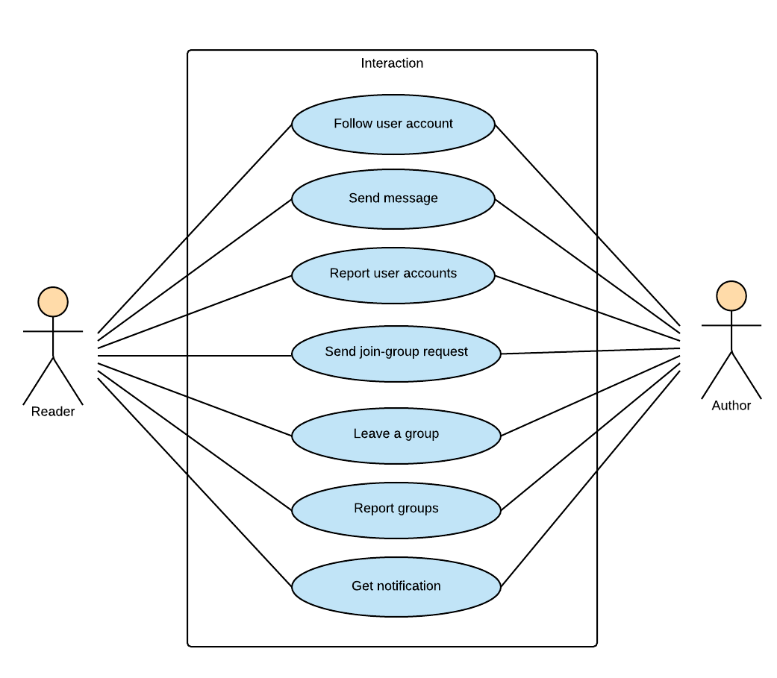

Figure 3‑4: Reader/Author Module-Interaction

##### 3.2.2.3.1 UC015-Follow user account

###### 3.2.2.3.1.1 Use Case Specification - Normal flow

|  |  |  |  |  |
| --- | --- | --- | --- | --- |
| **Use Case ID** | | UC017 | **Version** | 1.0 |
| **Use Case Name** | | Follow user account | | |
| **Created by:** | | HuyenPT | **Date Created:** | 10/21/2016 |
| **Primary Actor** | | Reader | **Secondary Actor** | Author |
| **Description:** | | This function allows user can follows the other and get update their actions like: posting, etc. | | |
| **Preconditions:** | | User logged in BSN website | | |
| **Trigger:** | | Click “Theo dõi” button in another user’s personal page | | |
| **Post conditions:** | | Display “Theo dõi” button change to “Đã theo dõi” button | | |
| **Normal Flow** | | | | |
| **Step** | **Actor** | **Action** | | |
| 1 | User | Go to another user’s personal page | | |
| 2 | BSN | Display other’s personal page includes:   * Navigation bar * Personal panel * Side bars   Recommendation area | | |
| 3 | User | Click “Theo dõi” button in other’s personal panel | | |
| 4 | BSN | Display “Theo dõi” button change to “Đã theo dõi” button | | |
| **Priority** | | High | | |
| **Frequency of Use:** | | High | | |
| **Business Rules:** | | N/A | | |
| **Other Information:** | | N/A | | |

###### 3.2.2.3.1.2 Alternative Flows and Exceptions

|  |  |  |
| --- | --- | --- |
| **Alternative Flows:** | | |
| **AT1** | At step 3 in the main flows, if user click other hyperlinks or buttons | |
| **Step** | **Actor** | **Action** |
| 3.1 | BSN | Redirects user to chosen hyperlink or button |
| **Exceptions: N/A** | | |

##### 3.2.2.3.2 UC016-Report user account

###### 3.2.2.3.2.1 Use Case Specification - Normal flow

|  |  |  |  |  |
| --- | --- | --- | --- | --- |
| **Use Case ID** | | UC016 | **Version** | 1.0 |
| **Use Case Name** | | Report user account | | |
| **Created by:** | | HuyenPT | **Date Created:** | 10/21/2016 |
| **Primary Actor** | | Reader | **Secondary Actor** | Author |
| **Description:** | | This function allows user report the other | | |
| **Preconditions:** | | User logged in BSN website | | |
| **Trigger:** | | Click “Báo cáo” button in another user’s personal page | | |
| **Post conditions:** | |  | | |
| **Normal Flow** | | | | |
| **Step** | **Actor** | **Action** | | |
| 1 | User | Go to another user’s personal page | | |
| 2 | BSN | Display other’s personal page includes:   * Navigation bar * Personal panel * Side bars   Recommendation area | | |
| 3 | User | Click “Báo cáo” button in other’s personal panel | | |
| 4 | BSN | Display popup with list of radio button includes:   * List of reasons   Text field to enter another reason | | |
| 5 | User | Choose a reason and click “Gửi” button | | |
| **Priority** | | High | | |
| **Frequency of Use:** | | High | | |
| **Business Rules:** | | N/A | | |
| **Other Information:** | | N/A | | |

###### 3.2.2.3.2.2 Alternative Flows and Exceptions

|  |  |  |  |  |
| --- | --- | --- | --- | --- |
| **Alternative Flows:** | | | | |
| **AT1** | At step 2 in the main flows, if user click other hyperlinks or buttons | | | |
| **Step** | **Actor** | | **Action** | |
| 2.1 | BSN | | Redirects user to chosen hyperlink or button | |
| **AT2** | At step 4 in the main flows, if user click close icon | | | |
| **Step** | **Actor** | | **Action** | |
| 2.1 | BSN | | Redirects user to chosen hyperlink or button | |
| **Exceptions:** | | | | |
| **EC1** | | At step 5 in the main flows, if user want to report by enter another reason but text field is null | | |
| **Step** | | **Actor** | | **Action** |
| 5.1 | | BSN | | Disable “Gửi” button |

##### 3.2.2.3.3 UC017-Send join-group request

###### 3.2.2.3.3.1 Use Case Specification - Normal flow

|  |  |  |  |  |
| --- | --- | --- | --- | --- |
| **Use Case ID** | | UC017 | **Version** | 1.0 |
| **Use Case Name** | | Send join-group request | | |
| **Created by:** | | HuyenPT | **Date Created:** | 10/21/2016 |
| **Primary Actor** | | Reader | **Secondary Actor** | Author |
| **Description:** | | This function allows user send request to join a group | | |
| **Preconditions:** | | User logged in BSN website | | |
| **Trigger:** | | Click “Tham gia” button in group page | | |
| **Post conditions:** | | Display “Tham gia” button change to “Đã gửi yêu cầu” button | | |
| **Normal Flow** | | | | |
| **Step** | **Actor** | **Action** | | |
| 1 | User | Go to group page | | |
| 2 | BSN | Display group page includes:   * Navigation bar * Group’s panel * Side bars   Posts area | | |
| 3 | User | Click “Tham gia” button in group’s panel | | |
| 4 | BSN | Display “Tham gia” button change to “Đã gửi yêu cầu” button | | |
| **Priority** | | High | | |
| **Frequency of Use:** | | High | | |
| **Business Rules:** | | N/A | | |
| **Other Information:** | | N/A | | |

###### 3.2.2.3.3.2 Alternative Flows and Exceptions

|  |  |  |
| --- | --- | --- |
| **Alternative Flows:** | | |
| **AT1** | At step 3 in the main flows, if user click other hyperlinks or buttons | |
| **Step** | **Actor** | **Action** |
| 3.1 | BSN | Redirects user to chosen hyperlink or button |
| **Exceptions: N/A** | | |

##### 3.2.2.3.4 UC018-Leave a group

###### 3.2.2.3.4.1 Use Case Specification - Normal flow

|  |  |  |  |  |
| --- | --- | --- | --- | --- |
| **Use Case ID** | | UC018 | **Version** | 1.0 |
| **Use Case Name** | | Leave a group | | |
| **Created by:** | | HuyenPT | **Date Created:** | 10/21/2016 |
| **Primary Actor** | | Reader | **Secondary Actor** | Author |
| **Description:** | | This function allows user out a group | | |
| **Preconditions:** | | 1. User logged in BSN website 2. User joined a group | | |
| **Trigger:** | | Click “Rời nhóm” button in group page | | |
| **Post conditions:** | | Display “Rời nhóm” button change to “Tham gia” button | | |
| **Normal Flow** | | | | |
| **Step** | **Actor** | **Action** | | |
| 1 | User | Go to group page | | |
| 2 | BSN | Display group page includes:   * Navigation bar * Group’s panel * Side bars   Posts area | | |
| 3 | User | Click “Rời nhóm” button in group’s panel | | |
| 4 | BSN | Display “Rời nhóm” button change to “Tham gia” button | | |
| **Priority** | | High | | |
| **Frequency of Use:** | | High | | |
| **Business Rules:** | | N/A | | |
| **Other Information:** | | N/A | | |

###### 3.2.2.3.4.2 Alternative Flows and Exceptions

|  |
| --- |
| **Alternative Flows: N/A** |
| **Exceptions: N/A** |

##### 3.2.2.3.5 UC019-Report a group

###### 3.2.2.3.5.1 Use Case Specification - Normal flow

|  |  |  |  |  |
| --- | --- | --- | --- | --- |
| **Use Case ID** | | UC019 | **Version** | 1.0 |
| **Use Case Name** | | Report a group | | |
| **Created by:** | | HuyenPT | **Date Created:** | 10/21/2016 |
| **Primary Actor** | | Reader | **Secondary Actor** | Author |
| **Description:** | | This function allows user report a group | | |
| **Preconditions:** | | 1. User logged in BSN website 2. User joined a group | | |
| **Trigger:** | | Click “Báo cáo” button in group page | | |
| **Post conditions:** | |  | | |
| **Normal Flow** | | | | |
| **Step** | **Actor** | **Action** | | |
| 1 | User | Go to group page | | |
| 2 | BSN | Display other’s personal page includes:   * Navigation bar * Group’s panel * Side bars   Posts area | | |
| 3 | User | Click “Báo cáo” button in group’s panel | | |
| 4 | BSN | Display popup with list of radio button includes:   * List of reasons   Text field to enter another reason | | |
| 5 | User | Choose a reason and click “Gửi” button | | |
| **Priority** | | High | | |
| **Frequency of Use:** | | High | | |
| **Business Rules:** | | N/A | | |
| **Other Information:** | | N/A | | |

###### 3.2.2.3.5.2 Alternative Flows and Exceptions

|  |  |  |  |  |
| --- | --- | --- | --- | --- |
| **Alternative Flows:** | | | | |
| **AT1** | At step 2 in the main flows, if user click other hyperlinks or buttons | | | |
| **Step** | **Actor** | | **Action** | |
| 2.1 | BSN | | Redirects user to chosen hyperlink or button | |
| **AT2** | At step 4 in the main flows, if user click close icon | | | |
| **Step** | **Actor** | | **Action** | |
| 4.1 | BSN | | Close popup | |
|  | | | | |
| **Exceptions:** | | | | |
| **EC1** | | At step 5 in the main flows, if user want to report by enter another reason but text field is null | | |
| **Step** | | **Actor** | | **Action** |
| 5.1 | | BSN | | Disable “Gửi” button |

##### 3.2.2.3.6 UC020-Get notification

###### 3.2.2.3.6.1 Use Case Specification - Normal flow

|  |  |  |  |  |
| --- | --- | --- | --- | --- |
| **Use Case ID** | | UC020 | **Version** | 1.0 |
| **Use Case Name** | | Get notification | | |
| **Created by:** | | HuyenPT | **Date Created:** | 10/21/2016 |
| **Primary Actor** | | Reader | **Secondary Actor** | Author |
| **Description:** | | This function allows user know about all activities related to that user | | |
| **Preconditions:** | | Login the BSN website | | |
| **Trigger:** | | Click bell icon in the navbar | | |
| **Post conditions:** | | Display notification | | |
| **Normal Flow** | | | | |
| **Step** | **Actor** | **Action** | | |
| 1 | User | Click bell icon in the navbar | | |
| 2 | BSN | Display notification | | |
| **Alternative Flows: N/A** | | | | |
| **Exceptions: N/A** | | | | |
| **Priority** | | High | | |
| **Frequency of Use:** | | High | | |
| **Business Rules:** | | N/A | | |
| **Other Information:** | | N/A | | |

###### 3.2.2.3.6.2 Alternative Flows and Exceptions

|  |
| --- |
| **Alternative Flows: N/A** |
| **Exceptions: N/A** |

#### 3.2.2.4 Group

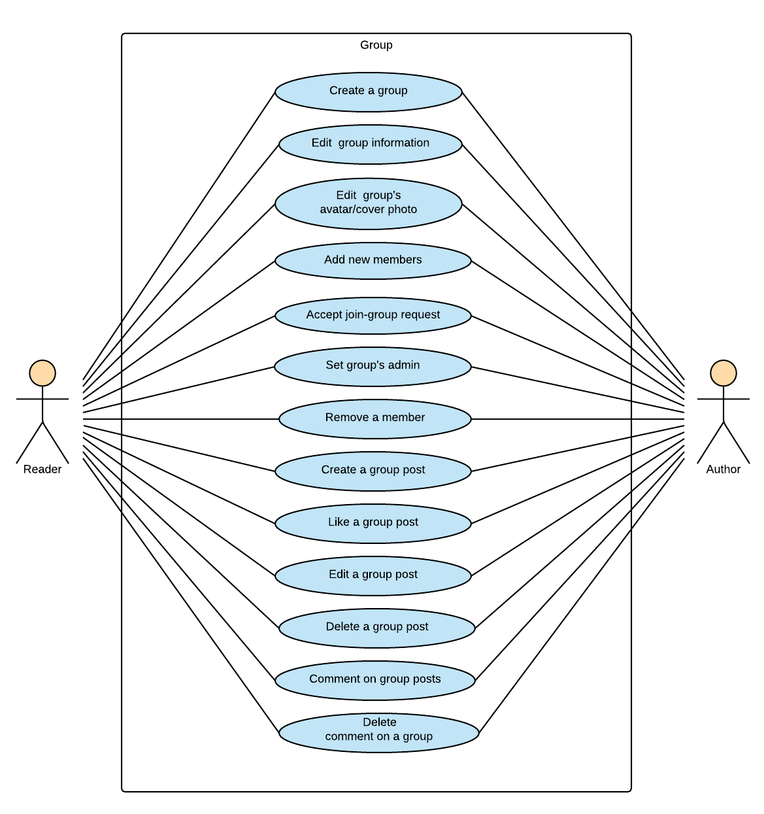

Figure 3‑5: Reader/Author Module-Group

##### 3.2.2.4.1 UC021-Create a group

###### 3.2.2.4.1.1 Use Case Specification - Normal flow

|  |  |  |  |  |
| --- | --- | --- | --- | --- |
| **Use Case ID** | | UC021 | **Version** | 1.0 |
| **Use Case Name** | | Create a group | | |
| **Created by:** | | HuyenPT | **Date Created:** | 10/21/2016 |
| **Primary Actor** | | Reader | **Secondary Actor** | Author |
| **Description:** | | This function allows user create a group | | |
| **Preconditions:** | | User logged in BSN website | | |
| **Trigger:** | | Click “Tạo nhóm” hyperlink in home page | | |
| **Post conditions:** | | New group has created | | |
| **Normal Flow** | | | | |
| **Step** | **Actor** | **Action** | | |
| 1 | User | Go to home page | | |
| 2 | BSN | Display home page includes:   * Navigation bar * Side bars   Posts area | | |
| 3 | User | Click “Tạo nhóm” button in home page | | |
| 4 | BSN | Display popup includes:   * Group name text box | | |
| 5 | User | Enter information and click “Tạo” button | | |
| **Priority** | | High | | |
| **Frequency of Use:** | | High | | |
| **Business Rules:** | | N/A | | |
| **Other Information:** | | N/A | | |

###### 3.2.2.4.1.2 Alternative Flows and Exceptions

|  |  |  |  |  |
| --- | --- | --- | --- | --- |
| **Alternative Flows:** | | | | |
| **AT1** | At step 2 in the main flows, if user click other hyperlinks or buttons | | | |
| **Step** | **Actor** | | **Action** | |
| 2.1 | BSN | | Redirects user to chosen hyperlink or button | |
| **AT1** | At step 2 in the main flows, if user click other hyperlinks or buttons | | | |
| **Step** | **Actor** | | **Action** | |
| 4.1 | BSN | | Close popup | |
|  | | | | |
| **Exceptions:** | | | | |
| **EC1** | | At step 5 in the main flows, if any text box is null | | |
| **Step** | | **Actor** | | **Action** |
| 5.1 | | BSN | | Disable “Tạo” button |

##### 3.2.2.4.2 UC022-Edit group information

###### 3.2.2.4.2.1 Use Case Specification - Normal flow

|  |  |  |  |  |
| --- | --- | --- | --- | --- |
| **Use Case ID** | | UC022 | **Version** | 1.0 |
| **Use Case Name** | | Edit group information | | |
| **Created by:** | | HuyenPT | **Date Created:** | 10/21/2016 |
| **Primary Actor** | | Reader | **Secondary Actor** | Author |
| **Description:** | | This function allows user to edit group profile | | |
| **Preconditions:** | | User logged in BSN website | | |
| **Trigger:** | | Click “Cài đặt” button in group page then click “Lưu” button after change group’s information | | |
| **Post conditions:** | | Display updated group’s information | | |
| **Normal Flow** | | | | |
| **Step** | **Actor** | **Action** | | |
| 1 | User | Go to group page | | |
| 2 | BSN | Display group page includes:   * Navigation bar * Group’s panel * Side bars   Posts area | | |
| 3 | User | Click “Cài đặt” button in home page | | |
| 4 | BSN | Display edit group profile page includes:   * Navigation bar * Group’s panel * Side bar   Information area | | |
| 5 | User | Enter information and click “Lưu” button | | |
| 6 | BSN | Display updated group’s information | | |
| **Priority** | | High | | |
| **Frequency of Use:** | | High | | |
| **Business Rules:** | | N/A | | |
| **Other Information:** | | N/A | | |

###### 3.2.2.4.2.2 Alternative Flows and Exceptions

|  |  |  |  |  |
| --- | --- | --- | --- | --- |
| **Alternative Flows:** | | | | |
| **AT1** | At step 2 in the main flows, if user click other hyperlinks or buttons | | | |
| **Step** | **Actor** | | **Action** | |
| 2.1 | BSN | | Redirects user to chosen hyperlink or button | |
|  | | | | |
| **Exceptions:** | | | | |
| **EC1** | | At step 5 in the main flows, if any text box is null | | |
| **Step** | | **Actor** | | **Action** |
| 5.1 | | BSN | | Show the corresponding error message |
| **EC2** | | At step 5 in the main flows, if any text box is entered wrong type of data | | |
| **Step** | | **Actor** | | **Action** |
| **5.1** | | BSN | | Show the corresponding error message |

##### 3.2.2.4.3 UC023-Edit group’s avatar and cover photo

###### 3.2.2.4.3.1 Use Case Specification - Normal flow

|  |  |  |  |  |
| --- | --- | --- | --- | --- |
| **Use Case ID** | | UC023 | **Version** | 1.0 |
| **Use Case Name** | | Edit group’s avatar and cover photo | | |
| **Created by:** | | HuyenPT | **Date Created:** | 10/21/2016 |
| **Primary Actor** | | Reader | **Secondary Actor** | Author |
| **Description:** | | This function allow admin of group edit cover and avatar photo | | |
| **Preconditions:** | | Go to group page | | |
| **Trigger:** | | Click on name of group | | |
| **Post conditions:** | | Avatar or cover photo of group is edited | | |
| **Normal Flow** | | | | |
| **Step** | **Actor** | **Action** | | |
| 1 | User | Go to group page | | |
| 2 | BSN | Display group page | | |
| 3 | User | 1. Click to camera icon to edit avatar and cover photo . 2. Choose photo | | |
| 4 | BSN | Update avatar and cover photo | | |
| **Priority** | | High | | |
| **Frequency of Use:** | | High | | |
| **Business Rules:** | | B3 | | |
| **Other Information:** | | N/A | | |

###### 3.2.2.4.3.2 Alternative Flows and Exceptions

|  |  |  |  |  |
| --- | --- | --- | --- | --- |
| **Alternative Flows:** | | | | |
| **AT1** | At step 3 in the main flows, if user click other hyperlinks or buttons | | | |
| **Step** | **Actor** | | **Action** | |
| 3.1 | BSN | | Redirects user to chosen hyperlink or button | |
| **Exceptions:** | | | | |
| **EC1** | | At step 3 in the main flows, if photo is not .jpg, .png | | |
| **Step** | | **Actor** | | **Action** |
| 3.1 | | BSN | | Display message MS32 |

##### 3.2.2.4.4 UC024-Add new member

###### 3.2.2.4.4.1 Use Case Specification - Normal flow

|  |  |  |  |  |
| --- | --- | --- | --- | --- |
| **Use Case ID** | | UC024 | **Version** | 1.0 |
| **Use Case Name** | | Add new member | | |
| **Created by:** | | HuyenPT | **Date Created:** | 10/21/2016 |
| **Primary Actor** | | Reader | **Secondary Actor** | Author |
| **Description:** | | This function allows user as an admin of group to add new member by enter account name | | |
| **Preconditions:** | | 1. User logged in BSN website 2. User is an admin of group | | |
| **Trigger:** | |  | | |
| **Post conditions:** | | New member has added in group | | |
| **Normal Flow** | | | | |
| **Step** | **Actor** | **Action** | | |
| 1 | User | Go to group page | | |
| 2 | BSN | Display group page includes:   * Navigation bar * Group’s panel * Side bars   Posts area | | |
| 3 | BSN | Display list account name | | |
| 4 | User | Choose an account name | | |
| 5 | BSN | Add new member in group | | |
| **Priority** | | High | | |
| **Frequency of Use:** | | High | | |
| **Business Rules:** | | N/A | | |
| **Other Information:** | | N/A | | |

###### 3.2.2.4.4.2 Alternative Flows and Exceptions

|  |  |  |
| --- | --- | --- |
| **Alternative Flows:** | | |
| **AT1** | At step 4 in the main flows, if BSN system cannot search any account name | |
| **Step** | **Actor** | **Action** |
| 4.1 | BSN | Display “Không tìm được người dùng” message |
| **Exceptions: N/A** | | |

##### 3.2.2.4.5 UC025-Accept join-group request

###### 3.2.2.4.5.1 Use Case Specification - Normal flow

|  |  |  |  |  |
| --- | --- | --- | --- | --- |
| **Use Case ID** | | UC025 | **Version** | 1.0 |
| **Use Case Name** | | Accept join-group request | | |
| **Created by:** | | HuyenPT | **Date Created:** | 10/21/2016 |
| **Primary Actor** | | Reader | **Secondary Actor** | Author |
| **Description:** | | This function allows user as an admin of group to add new member by accept their request | | |
| **Preconditions:** | | 1. User logged in BSN website 2. User is an admin of group | | |
| **Trigger:** | |  | | |
| **Post conditions:** | | New member has added in group | | |
| **Normal Flow** | | | | |
| **Step** | **Actor** | **Action** | | |
| 1 | User | Go to group page | | |
| 2 | BSN | Display group page includes:   * Navigation bar * Group’s panel * Side bars   Posts area | | |
| 3 | User | Click “Cài đặt” button, then click “Yêu cầu tham gia” tab | | |
| 4 | BSN | Display list join-request | | |
| 5 | User | Accept one or many request | | |
| 6 | BSN | Add new member in group | | |
| **Priority** | | High | | |
| **Frequency of Use:** | | High | | |
| **Business Rules:** | | N/A | | |
| **Other Information:** | | N/A | | |

###### 3.2.2.4.5.2 Alternative Flows and Exceptions

|  |
| --- |
| **Alternative Flows: N/A** |
| **Exceptions: N/A** |

##### 3.2.2.4.6 UC026-Set group’s admin

###### 3.2.2.4.6.1 Use Case Specification - Normal flow

|  |  |  |  |  |
| --- | --- | --- | --- | --- |
| **Use Case ID** | | UC026 | **Version** | 1.0 |
| **Use Case Name** | | Set group’s admin | | |
| **Created by:** | | HuyenPT | **Date Created:** | 10/21/2016 |
| **Primary Actor** | | Reader | **Secondary Actor** | Author |
| **Description:** | | This function allows user as an admin of group to set other be an admin | | |
| **Preconditions:** | | 1. User logged in BSN website 2. User is an admin of group | | |
| **Trigger:** | | Click “Thêm với tư cách quản lí” hyperlink on dropdown list in config icon in “Thành viên” tab | | |
| **Post conditions:** | | “Quản trị viên” sub-tab has new admin | | |
| **Normal Flow** | | | | |
| **Step** | **Actor** | **Action** | | |
| 1 | User | Go to group page | | |
| 2 | BSN | Display group page includes:   * Navigation bar * Group’s panel * Side bars   Posts area | | |
| 3 | User | Click “Thêm với tư cách quản lí” hyperlink on dropdown list in config icon in “Thành viên” tab | | |
| 4 | BSN | “Quản trị viên” sub-tab has new admin | | |
| **Priority** | | High | | |
| **Frequency of Use:** | | High | | |
| **Business Rules:** | | N/A | | |
| **Other Information:** | | N/A | | |

###### 3.2.2.4.6.2 Alternative Flows and Exceptions

|  |
| --- |
| **Alternative Flows: N/A** |
| **Exceptions: N/A** |

##### 3.2.2.4.7 UC027-Remove a member

###### 3.2.2.4.7.1 Use Case Specification - Normal flow

|  |  |  |  |  |
| --- | --- | --- | --- | --- |
| **Use Case ID** | | UC027 | **Version** | 1.0 |
| **Use Case Name** | | Remove a member | | |
| **Created by:** | | HuyenPT | **Date Created:** | 10/21/2016 |
| **Primary Actor** | | Reader | **Secondary Actor** | Author |
| **Description:** | | This function allows user as an admin of group to remove member out of group | | |
| **Preconditions:** | | 1. User logged in BSN website 2. User is an admin of group | | |
| **Trigger:** | | Click “Xóa khỏi nhóm” hyperlink on dropdown list in config icon in “Thành viên” tab | | |
| **Post conditions:** | | Number of members has decreased | | |
| **Normal Flow** | | | | |
| **Step** | **Actor** | **Action** | | |
| 1 | User | Go to group page | | |
| 2 | BSN | Display group page includes:   * Navigation bar * Group’s panel * Side bars   Posts area | | |
| 3 | User | Click “Xóa khỏi nhóm” hyperlink on dropdown list in config icon in “Thành viên” tab | | |
| 4 | BSN | Remove member and decrease number of members | | |
| **Priority** | | High | | |
| **Frequency of Use:** | | High | | |
| **Business Rules:** | | N/A | | |
| **Other Information:** | | N/A | | |

###### 3.2.2.4.7.2 Alternative Flows and Exceptions

|  |
| --- |
| **Alternative Flows: N/A** |
| **Exceptions: N/A** |

##### 3.2.2.4.8 UC028-Create group post

###### 3.2.2.4.8.1 Use Case Specification - Normal flow

|  |  |  |  |  |
| --- | --- | --- | --- | --- |
| **Use Case ID** | | UC028 | **Version** | 1.0 |
| **Use Case Name** | | Create group post | | |
| **Created by:** | | HuyenPT | **Date Created:** | 10/21/2016 |
| **Primary Actor** | | Reader | **Secondary Actor** | Author |
| **Description:** | | This function allow user create a group | | |
| **Preconditions:** | | User logged in BSN website | | |
| **Trigger:** | | Click "Tạo nhóm" on setting item in the navbar | | |
| **Post conditions:** | | Create group successfully | | |
| **Normal Flow** | | | | |
| **Step** | **Actor** | **Action** | | |
| 1 | User | Click “Tạo nhóm” on setting item | | |
| 2 | BSN | Display pop to create group | | |
| 3 | User | Input all information of group | | |
| 4 | User | Click “Thêm” button | | |
| 5 | BSN | Create new group | | |
| **Priority** | | High | | |
| **Frequency of Use:** | | High | | |
| **Business Rules:** | | N/A | | |
| **Other Information:** | | N/A | | |

###### 3.2.2.4.8.2 Alternative Flows and Exceptions

|  |  |  |  |  |
| --- | --- | --- | --- | --- |
| **Alternative Flows:** | | | | |
| **AT1** | At step 4 in the main flows, if user click other hyperlinks or buttons | | | |
| **Step** | **Actor** | | **Action** | |
| 1 | BSN | | Redirects user to chosen hyperlink or button | |
| **Exceptions:** | | | | |
| **EC1** | | At step 4 in the main flows, if user don’t input and click “Thêm” button | | |
| **Step** | | **Actor** | | **Action** |
| 1 | | User | | Don’t input anything and click “Thêm” button |
| 2 | | BSN | | Display the corresponding message |

##### 3.2.2.4.9 UC029-Like a group post

###### 3.2.2.4.9.1 Use Case Specification - Normal flow

|  |  |  |  |  |
| --- | --- | --- | --- | --- |
| **Use Case ID** | | UC029 | **Version** | 1.0 |
| **Use Case Name** | | Like a group post | | |
| **Created by:** | | HuyenPT | **Date Created:** | 10/21/2016 |
| **Primary Actor** | | Reader | **Secondary Actor** | Author |
| **Description:** | | This function allow user like a post of group | | |
| **Preconditions:** | | 1. User logged in BSN website 2. As one member of the group or admin of group | | |
| **Trigger:** | | Click “Like” button below post | | |
| **Post conditions:** | | Number of like is increased | | |
| **Normal Flow** | | | | |
| **Step** | **Actor** | **Action** | | |
| 1 | User | Go to BSN website | | |
| 2 | User | Create a group or join group | | |
| 3 | User | Click “Like” button | | |
| 4 | BSN | Calculates and displays the total number of likes | | |
| **Priority** | | High | | |
| **Frequency of Use:** | | High | | |
| **Business Rules:** | | N/A | | |
| **Other Information:** | | N/A | | |

###### 3.2.2.4.9.2 Alternative Flows and Exceptions

|  |  |  |
| --- | --- | --- |
| **Alternative Flows:** | | |
| **AT1** | At step 4 in the main flows, if user click other hyperlinks or buttons | |
| **Step** | **Actor** | **Action** |
| 1 | BSN | Redirects user to chosen hyperlink or button |
| **Exceptions: N/A** | | |

##### 3.2.2.4.10 UC030-Edit group post

###### 3.2.2.4.10.1 Use Case Specification - Normal flow

|  |  |  |  |  |
| --- | --- | --- | --- | --- |
| **Use Case ID** | | UC030 | **Version** | 1.0 |
| **Use Case Name** | | Edit group post | | |
| **Created by:** | | HuyenPT | **Date Created:** | 10/21/2016 |
| **Primary Actor** | | Reader | **Secondary Actor** | Author |
| **Description:** | | This function allow creators post edit group post | | |
| **Preconditions:** | | 1. User logged in BSN website 2. As creators post | | |
| **Trigger:** | | Click “Sửa” on the drop down list | | |
| **Post conditions:** | | Display all information of group to edit | | |
| **Normal Flow** | | | | |
| **Step** | **Actor** | **Action** | | |
| 1 | User | Go to BSN website | | |
| 2 | User | Click “Sửa” on drop down list | | |
| 3 | BSN | Display all information of group to edit | | |
| 4 | User | Edit information | | |
| 5 | User | Click “Lưu” button | | |
| 6 | BSN | Update information of group | | |
| **Priority** | | High | | |
| **Frequency of Use:** | | High | | |
| **Business Rules:** | | N/A | | |
| **Other Information:** | | N/A | | |

###### 3.2.2.4.10.2 Alternative Flows and Exceptions

|  |  |  |  |  |
| --- | --- | --- | --- | --- |
| **Alternative Flows:** | | | | |
| **AT1** | At step 5 in the main flows, if user click other hyperlinks or buttons | | | |
| **Step** | **Actor** | | **Action** | |
| 1 | BSN | | Redirects user to chosen hyperlink or button | |
| **Exceptions:** | | | | |
| **EC1** | | At step 5 in the main flows , if the user enters name of group empty | | |
| **Step** | | **Actor** | | **Action** |
| 1 | | User | | Enter name of group empty |
| 2 | | BSN | | Display message MS18 |
| **EC2** | | At step 5 in the main flows , if the user enters name of group already exists | | |
| **Step** | | **Actor** | | **Action** |
| **1** | | User | | Enter name of group already exists |
| **2** | | BSN | | Display message MS31 |

##### 3.2.2.4.11 UC031-Delete group post

###### 3.2.2.4.11.1 Use Case Specification - Normal flow

|  |  |  |  |  |
| --- | --- | --- | --- | --- |
| **Use Case ID** | | UC031 | **Version** | 1.0 |
| **Use Case Name** | | Delete group post | | |
| **Created by:** | | HuyenPT | **Date Created:** | 10/21/2016 |
| **Primary Actor** | | Reader | **Secondary Actor** | Author |
| **Description:** | | This function allow creators post or admin of group edit group post | | |
| **Preconditions:** | | 1. User logged in BSN website 2. As creators post or admin of group | | |
| **Trigger:** | | Click “Xóa” on the drop down list | | |
| **Post conditions:** | | Post was deleted | | |
| **Normal Flow** | | | | |
| **Step** | **Actor** | **Action** | | |
| 1 | User | Go to BSN website | | |
| 2 | User | Click “Xóa” on drop down list | | |
| 3 | BSN | Delete group post | | |
| **Priority** | | High | | |
| **Frequency of Use:** | | High | | |
| **Business Rules:** | | N/A | | |
| **Other Information:** | | N/A | | |

###### 3.2.2.4.11.2 Alternative Flows and Exceptions

|  |  |  |
| --- | --- | --- |
| **Alternative Flows:** | | |
| **AT1** | At step 2 in the main flows, if user click other hyperlinks or buttons | |
| **Step** | **Actor** | **Action** |
| 1 | BSN | Redirects user to chosen hyperlink or button |
| **Exceptions: N/A** | | |

##### 3.2.2.4.12 UC032-Comment on a group post

###### 3.2.2.4.12.1 Use Case Specification - Normal flow

|  |  |  |  |  |
| --- | --- | --- | --- | --- |
| **Use Case ID** | | UC032 | **Version** | 1.0 |
| **Use Case Name** | | Comment on a group post | | |
| **Created by:** | | HuyenPT | **Date Created:** | 10/21/2016 |
| **Primary Actor** | | Reader | **Secondary Actor** | Author |
| **Description:** | | This function allow user comment on a group post | | |
| **Preconditions:** | | 1. User logged in BSN website 2. As member of group | | |
| **Trigger:** | | Click textbox comment | | |
| **Post conditions:** | | Show comment on below the post | | |
| **Normal Flow** | | | | |
| **Step** | **Actor** | **Action** | | |
| 1 | User | Go to BSN website | | |
| 2 | User | Click comment textbox and enter content | | |
| 3 | User | Click “Đăng” button | | |
| 4 | BSN | Display comment | | |
| **Priority** | | High | | |
| **Frequency of Use:** | | High | | |
| **Business Rules:** | | N/A | | |
| **Other Information:** | | N/A | | |

###### 3.2.2.4.12.2 Alternative Flows and Exceptions

|  |  |  |
| --- | --- | --- |
| **Alternative Flows:** | | |
| **AT1** | At step 3 in the main flows, if user click other hyperlinks or buttons | |
| **Step** | **Actor** | **Action** |
| 1 | BSN | Redirects user to chosen hyperlink or button |
| **Exceptions: N/A** | | |

##### 3.2.2.4.13 UC033-Delete a comment on a group post

###### 3.2.2.4.13.1 Use Case Specification - Normal flow

|  |  |  |  |  |
| --- | --- | --- | --- | --- |
| **Use Case ID** | | UC033 | **Version** | 1.0 |
| **Use Case Name** | | Delete a comment on a group post | | |
| **Created by:** | | HuyenPT | **Date Created:** | 10/21/2016 |
| **Primary Actor** | | Reader | **Secondary Actor** | Author |
| **Description:** | | This function allow user delete comment of post | | |
| **Preconditions:** | | 1. User logged in BSN website 2. As commentator or creator’s post | | |
| **Trigger:** | | Click “Xóa” icon | | |
| **Post conditions:** | | The comment was deleted | | |
| **Normal Flow** | | | | |
| **Step** | **Actor** | **Action** | | |
| 1 | User | Go to BSN website | | |
| 2 | User | Click “Xóa” button | | |
| 3 | BSN | Comment was deleted | | |
| **Priority** | | High | | |
| **Frequency of Use:** | | High | | |
| **Business Rules:** | | N/A | | |
| **Other Information:** | | N/A | | |

###### 3.2.2.4.13.2 Alternative Flows and Exceptions

|  |
| --- |
| **Alternative Flows: N/A** |
| **Exceptions: N/A** |

#### 3.2.2.5 Book

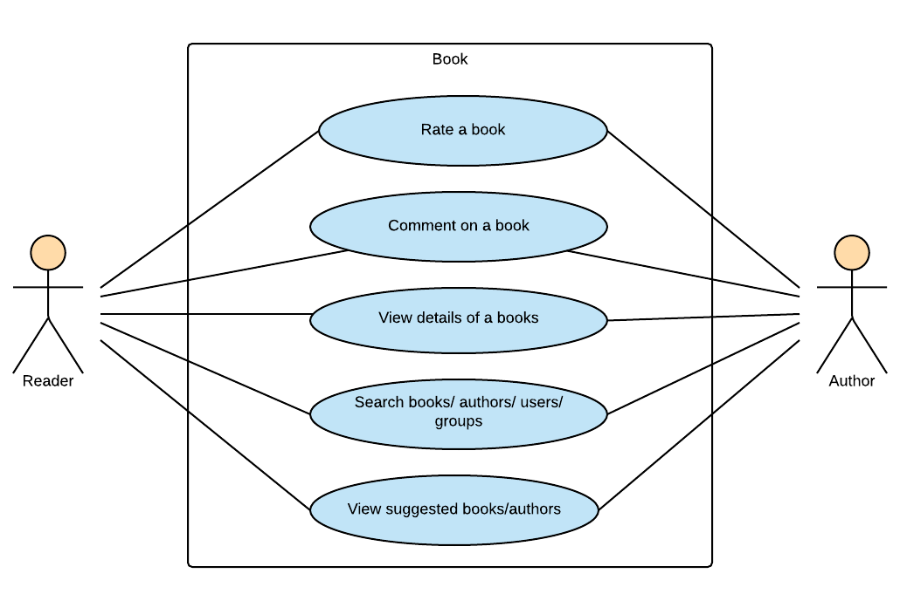

Figure 3‑6: Reader/Author Module-Book

##### 3.2.2.5.1 UC034-Rate a book

###### 3.2.2.5.1.1 Use Case Specification - Normal flow

|  |  |  |  |  |
| --- | --- | --- | --- | --- |
| **Use Case ID** | | UC034 | **Version** | 1.0 |
| **Use Case Name** | | Rate a book | | |
| **Created by:** | | HuyenPT | **Date Created:** | 10/21/2016 |
| **Primary Actor** | | Reader | **Secondary Actor** | Author |
| **Description:** | | This function allows user to rate a book | | |
| **Preconditions:** | | User logged in BSN website | | |
| **Trigger:** | | Click rating stars | | |
| **Post conditions:** | | Display rating point updated and rating success message | | |
| **Normal Flow** | | | | |
| **Step** | **Actor** | **Action** | | |
| 1 | User | Enter a book’s page | | |
| 2 | BSN | Display a book’s page includes:   * Book’s image * Book’s information * Rating stars * Comment area   Right side bar | | |
| 3 | User | Click rating stars between 1 – 5 star to rate this book | | |
| 4 | BSN | Display rating point updated and rating success message | | |
| **Priority** | | High | | |
| **Frequency of Use:** | | High | | |
| **Business Rules:** | | N/A | | |
| **Other Information:** | | N/A | | |

###### 3.2.2.5.1.2 Alternative Flows and Exceptions

|  |
| --- |
| **Alternative Flows: N/A** |
| **Exceptions: N/A** |

##### 3.2.2.5.2 UC035-Comment on a book

###### 3.2.2.5.2.1 Use Case Specification - Normal flow

|  |  |  |  |  |
| --- | --- | --- | --- | --- |
| **Use Case ID** | | UC035 | **Version** | 1.0 |
| **Use Case Name** | | Comment on a book | | |
| **Created by:** | | HuyenPT | **Date Created:** | 10/21/2016 |
| **Primary Actor** | | Reader | **Secondary Actor** | Author |
| **Description:** | | This function allows user to comment on a book | | |
| **Preconditions:** | | User logged in BSN website | | |
| **Trigger:** | | Press Enter in comment textbox | | |
| **Post conditions:** | | Display new comment | | |
| **Normal Flow** | | | | |
| **Step** | **Actor** | **Action** | | |
| 1 | User | Enter a book’s page | | |
| 2 | BSN | Display a book’s page includes:   * Book’s image * Book’s information * Rating stars * Comment area   Right side bar | | |
| 3 | User | Click on comment textbox and enter a comment then press Enter | | |
| 4 | BSN | Display new comment | | |
| **Priority** | | High | | |
| **Frequency of Use:** | | High | | |
| **Business Rules:** | | N/A | | |
| **Other Information:** | | N/A | | |

###### 3.2.2.5.2.2 Alternative Flows and Exceptions

|  |  |  |
| --- | --- | --- |
| **Alternative Flows:** | | |
| **AT1** | At step 2 in the main flows, if user click other hyperlinks or buttons | |
| **Step** | **Actor** | **Action** |
| 2.1 | BSN | Redirects user to chosen hyperlink or button |
| **Exceptions: N/A** | | |

##### 3.2.2.5.3 UC036-View book’s detail

3.2.2.5.3.1 Use Case Specification - Normal flow

|  |  |  |  |  |
| --- | --- | --- | --- | --- |
| **Use Case ID** | | UC036 | **Version** | 1.0 |
| **Use Case Name** | | View book’s detail | | |
| **Created by:** | | HuyenPT | **Date Created:** | 10/21/2016 |
| **Primary Actor** | | Reader | **Secondary Actor** | Author |
| **Description:** | | This function allows user to view book’s details | | |
| **Preconditions:** | | User logged in BSN website | | |
| **Trigger:** | | Click on “Xem thêm” hyperlink in book’s page | | |
| **Post conditions:** | | Display detail popup | | |
| **Normal Flow** | | | | |
| **Step** | **Actor** | **Action** | | |
| 1 | User | Enter a book’s page | | |
| 2 | BSN | Display a book’s page includes:   * Book’s image * Book’s information * Rating stars * Comment area   Right side bar | | |
| 3 | User | Click on “Xem thêm” hyperlink in book’s page | | |
| 4 | BSN | Display detail popup | | |
| **Priority** | | High | | |
| **Frequency of Use:** | | High | | |
| **Business Rules:** | | N/A | | |
| **Other Information:** | | N/A | | |

###### 3.2.2.5.3.2 Alternative Flows and Exceptions

|  |  |  |
| --- | --- | --- |
| **Alternative Flows:** | | |
| **AT1** | At step 2 in the main flows, if user click other hyperlinks or buttons | |
| **Step** | **Actor** | **Action** |
| 2.1 | BSN | Redirects user to chosen hyperlink or button |
| **Exceptions: N/A** | | |

##### 3.2.2.5.4 UC037-Search book/author/other account/group

3.2.2.5.4.1 Use Case Specification - Normal flow

|  |  |  |  |  |
| --- | --- | --- | --- | --- |
| **Use Case ID** | | UC037 | **Version** | 1.0 |
| **Use Case Name** | | Search book/ author/ other accounts | | |
| **Created by:** | | HuyenPT | **Date Created:** | 10/21/2016 |
| **Primary Actor** | | Reader | **Secondary Actor** | Author |
| **Description:** | | This function allows user to search book/ author/ other accounts | | |
| **Preconditions:** | | User logged in BSN website | | |
| **Trigger:** | | Enter book/ author/ other accounts into search textbox | | |
| **Post conditions:** | | Display suggest book/ author/ other accounts | | |
| **Normal Flow** | | | | |
| **Step** | **Actor** | **Action** | | |
| 1 | User | Enter a book’s page | | |
| 2 | BSN | Display a book’s page includes:   * Book’s image * Book’s information * Rating stars * Comment area   Right side bar | | |
| 3 | User | Click on comment textbox and enter a comment then press Enter | | |
| 4 | BSN | Display new comment | | |
| **Priority** | | High | | |
| **Frequency of Use:** | | High | | |
| **Business Rules:** | | N/A | | |
| **Other Information:** | | N/A | | |

###### 3.2.2.5.4.2 Alternative Flows and Exceptions

|  |  |  |
| --- | --- | --- |
| **Alternative Flows:** | | |
| **AT1** | At step 2 in the main flows, if user click other hyperlinks or buttons | |
| **Step** | **Actor** | **Action** |
| 2.1 | BSN | Redirects user to chosen hyperlink or button |
| **Exceptions: N/A** | | |

##### 3.2.2.5.5 UC038-View suggested book/author

3.2.2.5.5.1 Use Case Specification - Normal flow

|  |  |  |  |  |
| --- | --- | --- | --- | --- |
| **Use Case ID** | | UC038 | **Version** | 1.0 |
| **Use Case Name** | | View suggested book/author | | |
| **Created by:** | | HuyenPT | **Date Created:** | 10/21/2016 |
| **Primary Actor** | | Reader | **Secondary Actor** | Author |
| **Description:** | | This function allows user to view suggested book/ author | | |
| **Preconditions:** | | User logged in BSN website | | |
| **Trigger:** | | N/A | | |
| **Post conditions:** | | N/A | | |
| **Normal Flow** | | | | |
| **Step** | **Actor** | **Action** | | |
| 1 | User | Enter a BSN website | | |
| 2 | BSN | Display a home page includes:   * Navigation bar * Side bars with list of groups, suggested books and authors * Recommendation area   Newfeed | | |
| **Priority** | | High | | |
| **Frequency of Use:** | | High | | |
| **Business Rules:** | | N/A | | |
| **Other Information:** | | N/A | | |

###### 3.2.2.5.5.2 Alternative Flows and Exceptions

|  |  |  |
| --- | --- | --- |
| **Alternative Flows:** | | |
| **AT1** | At step 2 in the main flows, if user click other hyperlinks or buttons | |
| **Step** | **Actor** | **Action** |
| 2.1 | BSN | Redirects user to chosen hyperlink or button |
| **Exceptions: N/A** | | |

### 3.2.3 Admin Module

#### 3.2.3.1 User Accounts Management

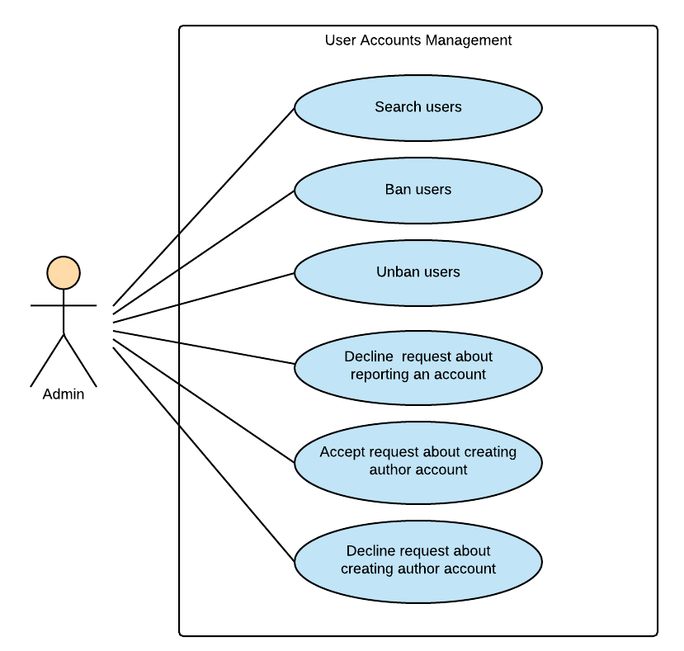

Figure 3‑7: Admin Module-User Accounts Management

##### 3.2.3.1.1 UC039-Search user

###### 3.2.3.1.1.1 Use Case Specification - Normal flow

|  |  |  |  |  |
| --- | --- | --- | --- | --- |
| **Use Case ID** | | UC039 | **Version** | 1.0 |
| **Use Case Name** | | Search user | | |
| **Created by:** | | HuyenPT | **Date Created:** | 10/21/2016 |
| **Primary Actor** | | Admin | **Secondary Actor** | N/A |
| **Description:** | | This function allow admin search user | | |
| **Preconditions:** | | Log in as admin | | |
| **Trigger:** | | Click search textbox | | |
| **Post conditions:** | |  | | |
| **Normal Flow** | | | | |
| **Step** | **Actor** | **Action** | | |
| 1 | Admin | Successful login as admin | | |
| 2 | Admin | Click search textbox | | |
| 3 | Admin | Enter name of user | | |
| 4 | BSN | Search and display the user | | |
| **Priority** | | High | | |
| **Frequency of Use:** | | High | | |
| **Business Rules:** | | N/A | | |
| **Other Information:** | | N/A | | |

###### 3.2.3.1.1.2 Alternative Flows and Exceptions

|  |
| --- |
| **Alternative Flows: N/A** |
| **Exceptions: N/A** |

##### 3.2.3.1.2 UC040-Ban user

###### 3.2.3.1.2.1 Use Case Specification - Normal flow

|  |  |  |  |  |
| --- | --- | --- | --- | --- |
| **Use Case ID** | | UC040 | **Version** | 1.0 |
| **Use Case Name** | | Ban user | | |
| **Created by:** | | HuyenPT | **Date Created:** | 11/25/2016 |
| **Primary Actor** | | Admin | **Secondary Actor** | N/A |
| **Description:** | | This function allow ban user | | |
| **Preconditions:** | | Log in as admin | | |
| **Trigger:** | | Click ban button | | |
| **Post conditions:** | | User will be banned | | |
| **Normal Flow** | | | | |
| **Step** | **Actor** | **Action** | | |
| 1 | Admin | Successful login as admin | | |
| 2 | Admin | Click ban button | | |
| 3 | BSN | Ban users | | |
| **Priority** | | High | | |
| **Frequency of Use:** | | High | | |
| **Business Rules:** | | N/A | | |
| **Other Information:** | | N/A | | |

###### 3.2.3.1.2.2 Alternative Flows and Exceptions

|  |
| --- |
| **Alternative Flows: N/A** |
| **Exceptions: N/A** |

##### 3.2.3.1.3 UC041-Unban user

###### 3.2.3.1.3.1 Use Case Specification - Normal flow

|  |  |  |  |  |
| --- | --- | --- | --- | --- |
| **Use Case ID** | | UC041 | **Version** | 1.0 |
| **Use Case Name** | | Unban user | | |
| **Created by:** | | HuyenPT | **Date Created:** | 11/25/2016 |
| **Primary Actor** | | Admin | **Secondary Actor** | N/A |
| **Description:** | | This function allow ban user | | |
| **Preconditions:** | | Log in as admin | | |
| **Trigger:** | | Click unban button | | |
| **Post conditions:** | | Unban users | | |
| **Normal Flow** | | | | |
| **Step** | **Actor** | **Action** | | |
| 1 | Admin | Successful login as admin | | |
| 2 | Admin | Click unban button | | |
| 3 | BSN | Unban users | | |
| **Priority** | | High | | |
| **Frequency of Use:** | | High | | |
| **Business Rules:** | | N/A | | |
| **Other Information:** | | N/A | | |

###### 3.2.3.1.3.2 Alternative Flows and Exceptions

|  |
| --- |
| **Alternative Flows: N/A** |
| **Exceptions: N/A** |

##### 3.2.3.1.4 UC043-Decline request reporting an account

###### 3.2.3.1.4.1 Use Case Specification - Normal flow

|  |  |  |  |  |
| --- | --- | --- | --- | --- |
| **Use Case ID** | | UC0 | **Version** | 1.0 |
| **Use Case Name** | | Decline request reporting an account | | |
| **Created by:** | | HuyenPT | **Date Created:** | 11/25/2016 |
| **Primary Actor** | | Admin | **Secondary Actor** | N/A |
| **Description:** | | This function allow admin decline request reporting an account | | |
| **Preconditions:** | | Successful login as admin | | |
| **Trigger:** | | Click decline request button | | |
| **Post conditions:** | | Request will be declined | | |
| **Normal Flow** | | | | |
| **Step** | **Actor** | **Action** | | |
| 1 | Admin | Successful login as admin | | |
| 2 | Admin | Click decline request button | | |
| 3 | BSN | Decline request reporting an account | | |
| **Priority** | | High | | |
| **Frequency of Use:** | | High | | |
| **Business Rules:** | | N/A | | |
| **Other Information:** | | N/A | | |

###### 3.2.3.1.4.2 Alternative Flows and Exceptions

|  |  |  |
| --- | --- | --- |
| **Alternative Flows:** | | |
| **AT1** | At step 2 in the main flows, if user click other hyperlinks or buttons | |
| **Step** | **Actor** | **Action** |
| 2.1 | BSN | Redirects user to chosen hyperlink or button |
| **Exceptions: N/A** | | |

##### 3.2.3.1.5 UC043-Accept request creating author account

###### 3.2.3.1.5.1 Use Case Specification - Normal flow

|  |  |  |  |  |
| --- | --- | --- | --- | --- |
| **Use Case ID** | | UC043 | **Version** | 1.0 |
| **Use Case Name** | | Accept request creating author account | | |
| **Created by:** | | HuyenPT | **Date Created:** | 11/25/2016 |
| **Primary Actor** | | Admin | **Secondary Actor** | N/A |
| **Description:** | | This function allow admin accept request creating author account | | |
| **Preconditions:** | | Successful login as admin | | |
| **Trigger:** | | Click accept button | | |
| **Post conditions:** | | Request creating author account will be accepted | | |
| **Normal Flow** | | | | |
| **Step** | **Actor** | **Action** | | |
| 1 | Admin | Successful login as admin | | |
| 2 | Admin | Click accept button | | |
| 3 | BSN | Request creating author account will be accepted | | |
| **Priority** | | High | | |
| **Frequency of Use:** | | High | | |
| **Business Rules:** | | N/A | | |
| **Other Information:** | | N/A | | |

###### 3.2.3.1.5.2 Alternative Flows and Exceptions

|  |  |  |
| --- | --- | --- |
| **Alternative Flows:** | | |
| **AT1** | At step 2 in the main flows, if user click other hyperlinks or buttons | |
| **Step** | **Actor** | **Action** |
| 2.1 | BSN | Redirects user to chosen hyperlink or button |
| **Exceptions: N/A** | | |

##### 3.2.3.1.6 UC044-Decline request creating author account

###### 3.2.3.1.6.1 Use Case Specification - Normal flow

|  |  |  |  |  |
| --- | --- | --- | --- | --- |
| **Use Case ID** | | UC044 | **Version** | 1.0 |
| **Use Case Name** | | Decline request creating author account | | |
| **Created by:** | | HuyenPT | **Date Created:** | 11/25/2016 |
| **Primary Actor** | | Admin | **Secondary Actor** | N/A |
| **Description:** | | This function allow admin decline request creating author account | | |
| **Preconditions:** | | Successful login as admin | | |
| **Trigger:** | | Click decline button | | |
| **Post conditions:** | | Request creating author account will be declined | | |
| **Normal Flow** | | | | |
| **Step** | **Actor** | **Action** | | |
| 1 | Admin | Successful login as admin | | |
| 2 | Admin | Click decline button | | |
| 3 | BSN | Request creating author account will be declined | | |
| **Priority** | | High | | |
| **Frequency of Use:** | | High | | |
| **Business Rules:** | | N/A | | |
| **Other Information:** | | N/A | | |

###### 3.2.3.1.6.2 Alternative Flows and Exceptions

|  |  |  |
| --- | --- | --- |
| **Alternative Flows:** | | |
| **AT1** | At step 2 in the main flows, if user click other hyperlinks or buttons | |
| **Step** | **Actor** | **Action** |
| 2.1 | BSN | Redirects user to chosen hyperlink or button |
| **Exceptions: N/A** | | |

#### 3.2.3.2 Groups Management

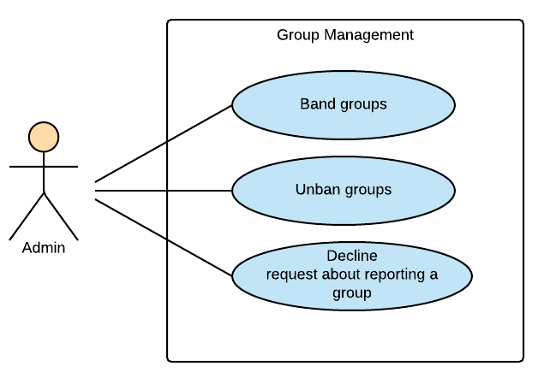

Figure 3‑8: Admin Module-Group Management

##### 3.2.3.2.1 UC045-Band a group

###### 3.2.3.2.1.1 Use Case Specification - Normal flow

|  |  |  |  |  |
| --- | --- | --- | --- | --- |
| **Use Case ID** | | UC045 | **Version** | 1.0 |
| **Use Case Name** | | Band a group | | |
| **Created by:** | | HuyenPT | **Date Created:** | 11/25/2016 |
| **Primary Actor** | | Admin | **Secondary Actor** | N/A |
| **Description:** | | This function allow admin ban a group | | |
| **Preconditions:** | | Successful login as admin | | |
| **Trigger:** | | Click ban button | | |
| **Post conditions:** | | Group was banned | | |
| **Normal Flow** | | | | |
| **Step** | **Actor** | **Action** | | |
| 1 | Admin | Successful login as admin | | |
| 2 | Admin | Click ban button | | |
| 3 | BSN | Ban group | | |
| **Priority** | | High | | |
| **Frequency of Use:** | | High | | |
| **Business Rules:** | | N/A | | |
| **Other Information:** | | N/A | | |

###### 3.2.3.2.1.2 Alternative Flows and Exceptions

|  |  |  |
| --- | --- | --- |
| **Alternative Flows:** | | |
| **AT1** | At step 2 in the main flows, if user click other hyperlinks or buttons | |
| **Step** | **Actor** | **Action** |
| 2.1 | BSN | Redirects user to chosen hyperlink or button |
| **Exceptions: N/A** | | |

##### 3.2.3.2.2 UC046-Unban a group

###### 3.2.3.2.2.1 Use Case Specification - Normal flow

|  |  |  |  |  |
| --- | --- | --- | --- | --- |
| **Use Case ID** | | UC046 | **Version** | 1.0 |
| **Use Case Name** | | Unban a group | | |
| **Created by:** | | HuyenPT | **Date Created:** | 11/25/2016 |
| **Primary Actor** | | Admin | **Secondary Actor** | N/A |
| **Description:** | | This function allow admin unban a group | | |
| **Preconditions:** | | Successful login as admin | | |
| **Trigger:** | | Click unban button | | |
| **Post conditions:** | | Group was unbanned | | |
| **Normal Flow** | | | | |
| **Step** | **Actor** | **Action** | | |
| 1 | Admin | Successful login as admin | | |
| 2 | Admin | Click unban button | | |
| 3 | BSN | Unban group | | |
| **Priority** | | High | | |
| **Frequency of Use:** | | High | | |
| **Business Rules:** | | N/A | | |
| **Other Information:** | | N/A | | |

###### 3.2.3.2.2.2 Alternative Flows and Exceptions

|  |  |  |
| --- | --- | --- |
| **Alternative Flows:** | | |
| **AT1** | At step 2 in the main flows, if user click other hyperlinks or buttons | |
| **Step** | **Actor** | **Action** |
| 2.1 | BSN | Redirects user to chosen hyperlink or button |
| **Exceptions: N/A** | | |

##### 3.2.3.2.3 UC047-Decline request reporting a group

###### 3.2.3.2.3.1 Use Case Specification - Normal flow

|  |  |  |  |  |
| --- | --- | --- | --- | --- |
| **Use Case ID** | | UC047 | **Version** | 1.0 |
| **Use Case Name** | | Decline request reporting a group | | |
| **Created by:** | | HuyenPT | **Date Created:** | 11/25/2016 |
| **Primary Actor** | | Admin | **Secondary Actor** | N/A |
| **Description:** | | This function allow admin decline request reporting a group | | |
| **Preconditions:** | | Successful login as admin | | |
| **Trigger:** | | Click decline request button | | |
| **Post conditions:** | | Request will be declined | | |
| **Normal Flow** | | | | |
| **Step** | **Actor** | **Action** | | |
| 1 | Admin | Successful login as admin | | |
| 2 | Admin | Click decline request button | | |
| 3 | BSN | Request will be declined | | |
| **Priority** | | High | | |
| **Frequency of Use:** | | High | | |
| **Business Rules:** | | N/A | | |
| **Other Information:** | | N/A | | |

###### 3.2.3.2.3.2 Alternative Flows and Exceptions

|  |  |  |
| --- | --- | --- |
| **Alternative Flows:** | | |
| **AT1** | At step 2 in the main flows, if user click other hyperlinks or buttons | |
| **Step** | **Actor** | **Action** |
| 2.1 | BSN | Redirects user to chosen hyperlink or button |
| **Exceptions: N/A** | | |

#### 3.2.3.3 Books Management

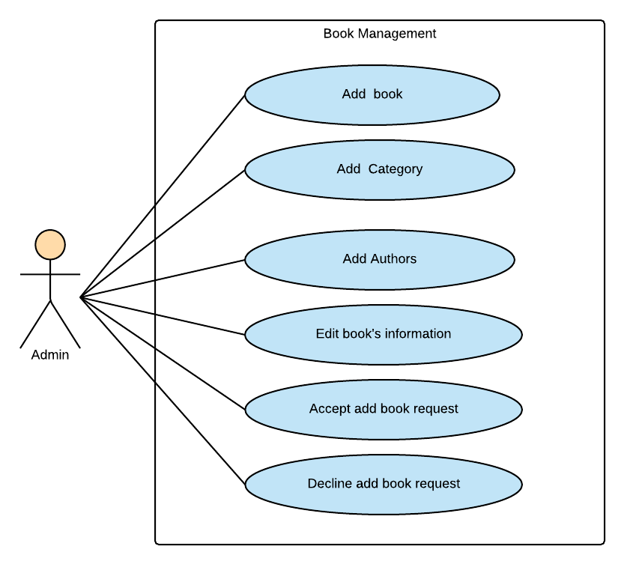

Figure 3‑9: Admin Module-Book Management

##### 3.2.3.3.1 UC048-Add a new book

###### 3.2.3.3.1.1 Use Case Specification - Normal flow

|  |  |  |  |  |
| --- | --- | --- | --- | --- |
| **Use Case ID** | | UC048 | **Version** | 1.0 |
| **Use Case Name** | | Add a new book | | |
| **Created by:** | | HuyenPT | **Date Created:** | 09/16/2016 |
| **Primary Actor** | | Admin | **Secondary Actor** | N/A |
| **Description:** | | This function allow admin add new book | | |
| **Preconditions:** | | Successful login as admin | | |
| **Trigger:** | | Click “Thêm sách” button | | |
| **Post conditions:** | | Popup to add new book is display then new book is added | | |
| **Normal Flow** | | | | |
| **Step** | **Actor** | **Action** | | |
| 1 | Admin | Successful login as admin | | |
| 2 | BSN | Popup add new book is displayed | | |
| 3 | Admin | Input all information of book | | |
| 4 | Admin | Click “Thêm” button | | |
| 5 | BSN | Books is added | | |
| **Priority** | | High | | |
| **Frequency of Use:** | | High | | |
| **Business Rules:** | | N/A | | |
| **Other Information:** | | N/A | | |

###### 3.2.3.3.1.2 Alternative Flows and Exceptions

|  |  |  |  |  |
| --- | --- | --- | --- | --- |
| **Alternative Flows:** | | | | |
| **AT1** | At step 4 in the main flows, if user click other hyperlinks or buttons | | | |
| **Step** | **Actor** | | **Action** | |
| 4.1 | BSN | | Redirects user to chosen hyperlink or button | |
| **Exceptions:** | | | | |
| **EC1** | | At step 4 in the main flows, if admin input name of book empty | | |
| **Step** | | **Actor** | | **Action** |
| 4.1 | | BSN | | Display message MS10 |
| **EC2** | | At step 4 in the main flows, if admin input name of author empty | | |
| **Step** | | **Actor** | | **Action** |
| 4.1 | | BSN | | Display message MS11 |
| **EC3** | | At step 4 in the main flows, if admin input category empty | | |
| **Step** | | **Actor** | | **Action** |
| 4.1 | | BSN | | Display message MS12 |
| **EC3** | | At step 4 in the main flows, if admin input publisher empty | | |
| **Step** | | **Actor** | | **Action** |
| 4.1 | | BSN | | Display message MS14 |
| **EC3** | | At step 4 in the main flows, if admin don’t choose image of book | | |
| **Step** | | **Actor** | | **Action** |
| 4.1 | | BSN | | Display message MS16 |
| **EC3** | | At step 4 in the main flows, if admin don’t choose date | | |
| **Step** | | **Actor** | | **Action** |
| 4.1 | | BSN | | Display message MS17 |

##### 3.2.3.3.2 UC050-Add a new category

###### 3.2.3.3.2.1 Use Case Specification - Normal flow

|  |  |  |  |  |
| --- | --- | --- | --- | --- |
| **Use Case ID** | | UC0 | **Version** | 1.0 |
| **Use Case Name** | | Add a new category | | |
| **Created by:** | | HuyenPT | **Date Created:** | 09/16/2016 |
| **Primary Actor** | | Admin | **Secondary Actor** | N/A |
| **Description:** | | This function allow admin add a new category | | |
| **Preconditions:** | | Successful login as admin | | |
| **Trigger:** | | Click “Thêm thể loại” button | | |
| **Post conditions:** | | Popup to add new category is displayed and new category is added | | |
| **Normal Flow** | | | | |
| **Step** | **Actor** | **Action** | | |
| 1 | Admin | Successful login as admin | | |
| 2 | BSN | Popup add new category is displayed | | |
| 3 | Admin | Input all information of category | | |
| 4 | Admin | Click “Thêm” button | | |
| 5 | BSN | Category is added | | |
| **Priority** | | High | | |
| **Frequency of Use:** | | High | | |
| **Business Rules:** | | N/A | | |
| **Other Information:** | | N/A | | |

###### 3.2.3.3.2.2 Alternative Flows and Exceptions

|  |  |  |  |  |
| --- | --- | --- | --- | --- |
| **Alternative Flows:** | | | | |
| **AT1** | At step 4 in the main flows, if user click other hyperlinks or buttons | | | |
| **Step** | **Actor** | | **Action** | |
| 4.1 | BSN | | Redirects user to chosen hyperlink or button | |
| **Exceptions:** | | | | |
| **EC1** | | At step 4 in the main flows, if admin input name of category empty | | |
| **Step** | | **Actor** | | **Action** |
| 4.1 | | BSN | | Display message MS26 |

##### 3.2.3.3.3 UC050-Add an author

###### 3.2.3.3.3.1 Use Case Specification - Normal flow

|  |  |  |  |  |
| --- | --- | --- | --- | --- |
| **Use Case ID** | | UC050 | **Version** | 1.0 |
| **Use Case Name** | | Add an author | | |
| **Created by:** | | HuyenPT | **Date Created:** | 09/16/2016 |
| **Primary Actor** | | Admin | **Secondary Actor** | N/A |
| **Description:** | | This function allow admin add a new author | | |
| **Preconditions:** | | Successful login as admin | | |
| **Trigger:** | |  | | |
| **Post conditions:** | | New author is added | | |
| **Normal Flow** | | | | |
| **Step** | **Actor** | **Action** | | |
| 1 | Admin | Successful login as admin | | |
| 2 | Admin | Click accept author account | | |
| 3 | BSN | Author account will be accepted | | |
| **Priority** | | High | | |
| **Frequency of Use:** | | High | | |
| **Business Rules:** | | N/A | | |
| **Other Information:** | | N/A | | |

###### 3.2.3.3.3.2 Alternative Flows and Exceptions

|  |  |  |
| --- | --- | --- |
| **Alternative Flows:** | | |
| **AT1** | At step 2 in the main flows, if user click other hyperlinks or buttons | |
| **Step** | **Actor** | **Action** |
| 2.1 | BSN | Redirects user to chosen hyperlink or button |
| **Exceptions: N/A** | | |

##### 3.2.3.3.4 UC051-Edit book's information

###### 3.2.3.3.4.1 Use Case Specification - Normal flow

|  |  |  |  |  |
| --- | --- | --- | --- | --- |
| **Use Case ID** | | UC051 | **Version** | 1.0 |
| **Use Case Name** | | Edit book's information | | |
| **Created by:** | | HuyenPT | **Date Created:** | 09/16/2016 |
| **Primary Actor** | | Admin | **Secondary Actor** | N/A |
| **Description:** | | This function allow admin edit book’s information | | |
| **Preconditions:** | | Successful login as admin | | |
| **Trigger:** | | Click to edit book button | | |
| **Post conditions:** | | Information of book will be edited | | |
| **Normal Flow** | | | | |
| **Step** | **Actor** | **Action** | | |
| 1 | Admin | Successful login as admin | | |
| 2 | Admin | Edit information of book | | |
| 3 | BSN | Update new information of book | | |
| **Priority** | | High | | |
| **Frequency of Use:** | | High | | |
| **Business Rules:** | | N/A | | |
| **Other Information:** | | N/A | | |

###### 3.2.3.3.4.2 Alternative Flows and Exceptions

|  |  |  |
| --- | --- | --- |
| **Alternative Flows:** | | |
| **AT1** | At step 2 in the main flows, if user click other hyperlinks or buttons | |
| **Step** | **Actor** | **Action** |
| 2.1 | BSN | Redirects user to chosen hyperlink or button |
| **Exceptions: N/A** | | |

##### 3.2.3.3.5 UC052-Accept add-book request

###### 3.2.3.3.5.1 Use Case Specification - Normal flow

|  |  |  |  |  |
| --- | --- | --- | --- | --- |
| **Use Case ID** | | UC052 | **Version** | 1.0 |
| **Use Case Name** | | Accept add-book request | | |
| **Created by:** | | HuyenPT | **Date Created:** | 09/16/2016 |
| **Primary Actor** | | Admin | **Secondary Actor** | N/A |
| **Description:** | | This function allow admin accept add book request | | |
| **Preconditions:** | | Successful login as admin | | |
| **Trigger:** | | Click accept button | | |
| **Post conditions:** | | Request add book will be accepted | | |
| **Normal Flow** | | | | |
| **Step** | **Actor** | **Action** | | |
| 1 | Admin | Successful login as admin | | |
| 2 | Admin | Click accept button | | |
| 3 | BSN | Request creating author account will be accepted | | |
| **Priority** | | High | | |
| **Frequency of Use:** | | High | | |
| **Business Rules:** | | N/A | | |
| **Other Information:** | | N/A | | |

###### 3.2.3.3.5.2 Alternative Flows and Exceptions

|  |  |  |
| --- | --- | --- |
| **Alternative Flows:** | | |
| **AT1** | At step 2 in the main flows, if user click other hyperlinks or buttons | |
| **Step** | **Actor** | **Action** |
| 2.1 | BSN | Redirects user to chosen hyperlink or button |
| **Exceptions: N/A** | | |

##### 3.2.3.3.6 UC053-Decline add-book request

###### 3.2.3.3.6.1 Use Case Specification - Normal flow

|  |  |  |  |  |
| --- | --- | --- | --- | --- |
| **Use Case ID** | | UC053 | **Version** | 1.0 |
| **Use Case Name** | | Decline add-book request | | |
| **Created by:** | | HuyenPT | **Date Created:** | 09/16/2016 |
| **Primary Actor** | | Admin | **Secondary Actor** | N/A |
| **Description:** | | This function allow admin decline request add book | | |
| **Preconditions:** | | Successful login as admin | | |
| **Trigger:** | | Click decline request button | | |
| **Post conditions:** | | Request will be declined | | |
| **Normal Flow** | | | | |
| **Step** | **Actor** | **Action** | | |
| 1 | Admin | Successful login as admin | | |
| 2 | Admin | Click decline request button | | |
| 3 | BSN | Request will be declined | | |
| **Priority** | | High | | |
| **Frequency of Use:** | | High | | |
| **Business Rules:** | | N/A | | |
| **Other Information:** | | N/A | | |

###### 3.2.3.3.6.2 Alternative Flows and Exceptions

|  |  |  |
| --- | --- | --- |
| **Alternative Flows:** | | |
| **AT1** | At step 2 in the main flows, if user click other hyperlinks or buttons | |
| **Step** | **Actor** | **Action** |
| 2.1 | BSN | Redirects user to chosen hyperlink or button |
| **Exceptions: N/A** | | |

#### 3.2.3.4 Sliders Management

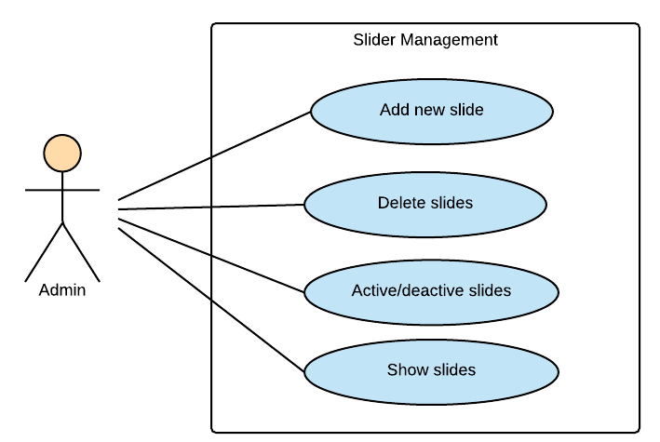

Figure 3‑10: Admin Module-Slider Management

##### 3.2.3.4.1 UC054-Add a new slider

###### 3.2.3.4.1.1 Use Case Specification - Normal flow

|  |  |  |  |  |
| --- | --- | --- | --- | --- |
| **Use Case ID** | | UC054 | **Version** | 1.0 |
| **Use Case Name** | | Add a new slider | | |
| **Created by:** | | HuyenPT | **Date Created:** | 09/16/2016 |
| **Primary Actor** | | Admin | **Secondary Actor** | N/A |
| **Description:** | | This function allow admin add a new slider | | |
| **Preconditions:** | | Successful login as admin | | |
| **Trigger:** | |  | | |
| **Post conditions:** | | New slider is added | | |
| **Normal Flow** | | | | |
| **Step** | **Actor** | **Action** | | |
| 1 | Admin | Successful login as admin | | |
| 2 | Admin | Click add slider | | |
| 3 | Admin | Input all field to add slider | | |
| 4 | Admin | Click “Thêm” button | | |
| 5 | BSN | Slider will be accepted | | |
| **Priority** | | High | | |
| **Frequency of Use:** | | High | | |
| **Business Rules:** | | B3 | | |
| **Other Information:** | | N/A | | |

###### 3.2.3.4.1.2Alternative Flows and Exceptions

|  |  |  |  |  |
| --- | --- | --- | --- | --- |
| **Alternative Flows:** | | | | |
| **AT1** | At step 4 in the main flows, if user click other hyperlinks or buttons | | | |
| **Step** | **Actor** | | **Action** | |
| 4.1 | BSN | | Redirects user to chosen hyperlink or button | |
| **Exceptions:** | | | | |
| **EC1** | | At step 4 in the main flows, if admin add photo is not .jpg, .png | | |
| **Step** | | **Actor** | | **Action** |
| 4.1 | | BSN | | Display message MS32 |

##### 3.2.3.4.2 UC055-Delete a slider

###### 3.2.3.4.2.1 Use Case Specification - Normal flow

|  |  |  |  |  |
| --- | --- | --- | --- | --- |
| **Use Case ID** | | UC055 | **Version** | 1.0 |
| **Use Case Name** | | Delete a slider | | |
| **Created by:** | | HuyenPT | **Date Created:** | 09/16/2016 |
| **Primary Actor** | | Admin | **Secondary Actor** | N/A |
| **Description:** | | This function allow admin delete a slider | | |
| **Preconditions:** | | Successful login as admin | | |
| **Trigger:** | | Click delete button | | |
| **Post conditions:** | | Slider will be deleted | | |
| **Normal Flow** | | | | |
| **Step** | **Actor** | **Action** | | |
| 1 | Admin | Successful login as admin | | |
| 2 | Admin | Click add slider | | |
| 3 | BSN | Slider was deleted | | |
| **Priority** | | High | | |
| **Frequency of Use:** | | High | | |
| **Business Rules:** | | N/A | | |
| **Other Information:** | | N/A | | |

###### 3.2.3.4.2.2 Alternative Flows and Exceptions

|  |  |  |
| --- | --- | --- |
| **Alternative Flows:** | | |
| **AT1** | At step 2 in the main flows, if user click other hyperlinks or buttons | |
| **Step** | **Actor** | **Action** |
| 2.1 | BSN | Redirects user to chosen hyperlink or button |
| **Exceptions: N/A** | | |

##### 3.2.3.4.3 UC056-Active/de-active a slider

###### 3.2.3.4.3.1 Use Case Specification - Normal flow

|  |  |  |  |  |
| --- | --- | --- | --- | --- |
| **Use Case ID** | | UC056 | **Version** | 1.0 |
| **Use Case Name** | | Active/de-active a slider | | |
| **Created by:** | | HuyenPT | **Date Created:** | 09/16/2016 |
| **Primary Actor** | | Admin | **Secondary Actor** | N/A |
| **Description:** | | This function allow admin active/de-active a slider | | |
| **Preconditions:** | | Successful login as admin | | |
| **Trigger:** | | Click active/de-active button | | |
| **Post conditions:** | | Slider will be active/de-active | | |
| **Normal Flow** | | | | |
| **Step** | **Actor** | **Action** | | |
| 1 | Admin | Successful login as admin | | |
| 2 | Admin | Click active/de-active button | | |
| 3 | BSN | Slider will be active/de-active | | |
| **Priority** | | High | | |
| **Frequency of Use:** | | High | | |
| **Business Rules:** | | N/A | | |
| **Other Information:** | | N/A | | |

###### 3.2.3.4.3.2 Alternative Flows and Exceptions

|  |  |  |
| --- | --- | --- |
| **Alternative Flows:** | | |
| **AT1** | At step 2 in the main flows, if user click other hyperlinks or buttons | |
| **Step** | **Actor** | **Action** |
| 2.1 | BSN | Redirects user to chosen hyperlink or button |
| **Exceptions: N/A** | | |

##### 3.2.3.4.4 UC057-Show a slider

###### 3.2.3.4.4.1 Use Case Specification - Normal flow

|  |  |  |  |  |
| --- | --- | --- | --- | --- |
| **Use Case ID** | | UC057 | **Version** | 1.0 |
| **Use Case Name** | | Show a slider | | |
| **Created by:** | | HuyenPT | **Date Created:** | 09/16/2016 |
| **Primary Actor** | | Admin | **Secondary Actor** | N/A |
| **Description:** | | This function allow admin view all slider | | |
| **Preconditions:** | | Successful login as admin | | |
| **Trigger:** | |  | | |
| **Post conditions:** | | Can view all slider of BSN website | | |
| **Normal Flow** | | | | |
| **Step** | **Actor** | **Action** | | |
| 1 | Admin | Successful login as admin | | |
| 2 | BSN | Show all slider of BSN website | | |
| **Priority** | | High | | |
| **Frequency of Use:** | | High | | |
| **Business Rules:** | | N/A | | |
| **Other Information:** | | N/A | | |

###### 3.2.3.4.4.2 Alternative Flows and Exceptions

|  |
| --- |
| **Alternative Flows: N/A** |
| **Exceptions: N/A** |

#### 3.2.3.5 Publishers Management

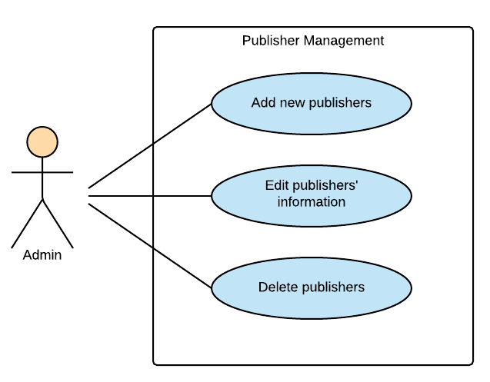

Figure 3‑11: Admin Module Publisher Management

##### 3.2.3.5.1 UC058-Add a new publisher

###### 3.2.3.5.1.1 Use Case Specification - Normal flow

|  |  |  |  |  |
| --- | --- | --- | --- | --- |
| **Use Case ID** | | UC058 | **Version** | 1.0 |
| **Use Case Name** | | Add a new publisher | | |
| **Created by:** | | HuyenPT | **Date Created:** | 09/16/2016 |
| **Primary Actor** | | Admin | **Secondary Actor** | N/A |
| **Description:** | | This function allow admin add a new publisher | | |
| **Preconditions:** | | Successful login as admin | | |
| **Trigger:** | | Click add publisher button | | |
| **Post conditions:** | | Publisher is added | | |
| **Normal Flow** | | | | |
| **Step** | **Actor** | **Action** | | |
| 1 | Admin | Successful login as admin | | |
| 2 | Admin | Click add publisher | | |
| 3 | Admin | Input all field to add publisher | | |
| 4 | Admin | Click “Thêm” button | | |
| 5 | BSN | Publisher is added | | |
| **Priority** | | High | | |
| **Frequency of Use:** | | High | | |
| **Business Rules:** | | N/A | | |
| **Other Information:** | | N/A | | |

###### 3.2.3.5.1.2 Alternative Flows and Exceptions

|  |  |  |  |  |
| --- | --- | --- | --- | --- |
| **Alternative Flows:** | | | | |
| **AT1** | At step 4 in the main flows, if user click other hyperlinks or buttons | | | |
| **Step** | **Actor** | | **Action** | |
| 4.1 | BSN | | Redirects user to chosen hyperlink or button | |
| **Exceptions:** | | | | |
| **EC1** | | At step 4 in the main flows, if admin add photo is not .jpg, .png | | |
| **Step** | | **Actor** | | **Action** |
| 4.1 | | BSN | | Display message MS32 |

##### 3.2.3.5.2 UC059-Edit publisher's information

###### 3.2.3.5.2.1 Use Case Specification - Normal flow

|  |  |  |  |  |
| --- | --- | --- | --- | --- |
| **Use Case ID** | | UC059 | **Version** | 1.0 |
| **Use Case Name** | | Edit publisher's information | | |
| **Created by:** | | HuyenPT | **Date Created:** | 09/16/2016 |
| **Primary Actor** | | Admin | **Secondary Actor** | N/A |
| **Description:** | | This function allow admin edit publisher's information | | |
| **Preconditions:** | | Successful login as admin | | |
| **Trigger:** | | Click to edit publisher button | | |
| **Post conditions:** | | Information of publisher will be edited | | |
| **Normal Flow** | | | | |
| **Step** | **Actor** | **Action** | | |
| 1 | Admin | Successful login as admin | | |
| 2 | Admin | Edit information of publisher | | |
| 3 | BSN | Update new information of publisher | | |
| **Priority** | | High | | |
| **Frequency of Use:** | | High | | |
| **Business Rules:** | | N/A | | |
| **Other Information:** | | N/A | | |

###### 3.2.3.5.2.2 Alternative Flows and Exceptions

|  |  |  |
| --- | --- | --- |
| **Alternative Flows:** | | |
| **AT1** | At step 2 in the main flows, if user click other hyperlinks or buttons | |
| **Step** | **Actor** | **Action** |
| 2.1 | BSN | Redirects user to chosen hyperlink or button |
| **Exceptions: N/A** | | |

##### 3.2.3.5.3 UC060-Delete a publisher

###### 3.2.3.5.3.1 Use Case Specification - Normal flow

|  |  |  |  |  |
| --- | --- | --- | --- | --- |
| **Use Case ID** | | UC060 | **Version** | 1.0 |
| **Use Case Name** | | Delete a publisher | | |
| **Created by:** | | HuyenPT | **Date Created:** | 09/16/2016 |
| **Primary Actor** | | Admin | **Secondary Actor** | N/A |
| **Description:** | | This function allow admin delete a publisher | | |
| **Preconditions:** | | Successful login as admin | | |
| **Trigger:** | | Click delete button | | |
| **Post conditions:** | | Publisher is deleted | | |
| **Normal Flow** | | | | |
| **Step** | **Actor** | **Action** | | |
| 1 | Admin | Successful login as admin | | |
| 2 | Admin | Click delete button | | |
| 3 | BSN | Publisher is deleted | | |
| **Priority** | | High | | |
| **Frequency of Use:** | | High | | |
| **Business Rules:** | | N/A | | |
| **Other Information:** | | N/A | | |

###### 3.2.3.5.3.2 Alternative Flows and Exceptions

|  |  |  |
| --- | --- | --- |
| **Alternative Flows:** | | |
| **AT1** | At step 2 in the main flows, if user click other hyperlinks or buttons | |
| **Step** | **Actor** | **Action** |
| 2.1 | BSN | Redirects user to chosen hyperlink or button |
| **Exceptions: N/A** | | |

#### 3.2.3.6 Statistics

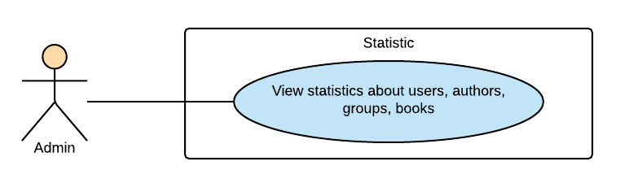

Figure 3‑12: Admin Module-Statistics

##### 3.2.3.6.1 UC061-View statistic

###### 3.2.3.6.1.1 Use Case Specification - Normal flow

|  |  |  |  |  |
| --- | --- | --- | --- | --- |
| **Use Case ID** | | UC061 | **Version** | 1.0 |
| **Use Case Name** | | View statistic | | |
| **Created by:** | | HuyenPT | **Date Created:** | 11/25/2016 |
| **Primary Actor** | | Admin | **Secondary Actor** | N/A |
| **Description:** | | This function allow admin view statistic | | |
| **Preconditions:** | | Successful login as admin | | |
| **Trigger:** | |  | | |
| **Post conditions:** | | Can view statistic | | |
| **Normal Flow** | | | | |
| **Step** | **Actor** | **Action** | | |
| 1 | Admin | Successful login as admin | | |
| 2 | BSN | Show all statistic | | |
| **Priority** | | High | | |
| **Frequency of Use:** | | High | | |
| **Business Rules:** | | N/A | | |
| **Other Information:** | | N/A | | |

###### 3.2.3.6.1.2 Alternative Flows and Exceptions

|  |
| --- |
| **Alternative Flows: N/A** |
| **Exceptions: N/A** |

# NON-FUNCTIONAL SPECIFICATION

## **Reliability**

1. Mean time between failures: The mean time between each failure is expected to be about 480 hours of using.
2. The maximum bugs per function are 2 bugs/a function when user uses software within 2 months. The average number of bugs in the software during system testing is about to be around 1 bugs/KLOC.
3. The database must be backed up daily and can be recovered if necessary

## **Performance Requirements**

### **Availability**

The application must be available 95% of time. Users can access to it everywhere from their Web browser with internet connection.

### **Response time**

In term of response time, waiting time of processing will be 2 to 5 seconds; time to process any functions will not exceed 7 seconds.

### **Maintainability**

* **Coding standards and naming conventions**
  + Output of the project must include coding standards and naming conventions documentations. Implementation code must be easy to maintain.
  + If some components are reused, the documentations of those components must also be included.
* **Design**
  + The design of the system must be loosely coupled that chances on some module will not affect others.
* **Logging**
  + All the errors should be logged, supporting for bug fixing and maintenance.
  + All strange or sensitive situations should also be logged.
* **Mean time to repair:** Immediately when Administrator finds out problem or website is attacked/ hacked by someone. Average 1 day.

### **Usability**

Usability Requirements support the following from the perspective of its primary users:

● **Efficiency of use:** user can complete each function in less than 12 actions

● **Intuitiveness:** User can understand approximately 90% help/ error messages

### **Security Requirements**

In order to avoid unwanted access by strangers, the security implemented in various ways:

1. **User authorize**: Each function must be distributed system access and manipulate the individual parts. To edit information, user must declare their username and password before the operation. Functions will be show after users login dependencies user’s role and permission of each user.
2. **Manage Data Layer**: Only Administrator can modify database system.

### **Hardware/Software Requirements**

● **Hardware requirement:**

**- Server:** Web service 2013, IIS8

**- Client:** PC/Laptop (window 7, window 8, window 10)

● **Software requirements:** Web browser (Chrome 50.0 or higher) with internet connection